Skillshare360

Requirements Specification

Version 1.0

April 19, 2021

**Table of Contents**

Executive Summary 3

1.1 Project Overview 3

Our online learning platform is a web-based application created to give learners access to educational materials and content, including video lectures, interactive tests, and readings. Our platform is built to meet the needs of a variety of learners, including lifelong learners, professionals, and students. 3

1.2 Purpose and Scope of this Specification 3

2. Product/service description 4

2.1 Product Context 4

2.2 User Characteristics 4

2.3 Assumptions 5

2.4 Constraints 6

2.5 Dependencies 6

3. Requirements 7

3.1 Functional Requirements 7

3.2 Non-Functional Requirements 11

3.2.1 Product Requirements 11

3.2.1.1 **User Interface Requirements** 11

3.2.1.2 **Usability** 11

3.2.1.3 **Efficiency** 12

3.2.1.3.1 Performance Requirements 12

3.2.1.3.2 Space Requirements 12

3.2.1.4 **Dependability** 12

3.2.1.5 **Security** 12

3.2.2 Organizational Requirements 13

3.2.2.1 **Environmental Requirements** 13

3.2.2.2 **Operational Requirements** 13

3.2.2.3 **Development Requirements** 13

3.2.3 External Requirements 13

3.2.3.1 **Regulatory Requirements** 13

3.2.3.2 **Ethical Requirements** 13

3.2.3.3 **Legislative Requirements** 13

3.2.3.3.1 Accounting Requirements 13

3.2.3.3.2 Security Requirements 13

3.3 Domain Requirements 13

A.1.1.1. 13

4. User Scenarios/Use Cases 13

4.1 User Scenarios 7  
4.2 Use Cases 7  
4.3 Use Cases Extended 7  
4.4 BPMN 7  
4.5 Data Flow Diagram 7  
4.6 Entity-Relationship Diagram 7  
4.7 Activity Diagrams 7  
4.8 Timing Diagram 7  
4.9 State Diagram 7  
4.10 Sequence Diagrams 7  
4.11 Collaboration Diagrams 7  
4.12 Class Diagram 7  
4.13 Object Diagram 7  
4.14 Package Diagram 7  
4.15 Component Diagram 7  
4.16 Deployment Diagram 7

**5. Design Patterns 7**

**6. Appendix** **7**

# Executive Summary

## Project Overview

## Our online learning platform is a web-based application created to give learners access to educational materials and content, including video lectures, interactive tests, and readings. Our platform is built to meet the needs of a variety of learners, including lifelong learners, professionals, and students.

## Purpose and Scope of this Specification

The purpose of this project is to develop an online learning platform that provides learners with access to high-quality educational content and resources. The platform will be designed to cater to the needs of different types of learners, including students, professionals, and lifelong learners.

Within the scope:

* Design and development of the user interface, database, and functionality for the online learning platform.
* Producing and collecting educational materials and information, including reading materials, interactive quizzes, and video lectures.
* Features for user registration, authentication, and account administration.
* The use of customized learning environments that take into account the unique requirements and preferences of each student.
* Connectivity with tools and platforms from other companies, such as payment gateways, email marketing applications, and social media sites.
* The platform's quality control and testing to make sure it is dependable, secure, and available to all users.
* The platform's deployment to a reputable hosting environment.

Outside the scope:

* Development of user-specific hardware or software.
* Creating unique material for particular clients or groups.
* Localization of the platform to fit different linguistic or cultural backgrounds.
* Reaching out to potential users to market or promote the platform.
* The platform's ongoing maintenance and support after its first deployment.
* Creating mobile applications that go beyond the platform's basic features.
* Platform customization that goes beyond the predetermined needs and standards.

# Product/service description

Skillshare360 is an online learning platform that offers a wide range of courses and tutorials on various subjects and skills. The platform is designed to provide learners with a personalized and interactive learning experience, allowing them to access high-quality educational content and connect with a community of like-minded learners and instructors.

The website offers courses on diverse topics such as business, technology, design, photography, music, art, and more. These courses are created and taught by experienced instructors, who bring their expertise and insights to the platform. Users can sign up for free and create a profile, which allows them to browse and enroll in courses that suit their learning objectives and preferences, access them from anywhere.

The flexible interface allows learners to navigate through courses, track their progress, and interact with other learners and instructors. The platform provides various features such as quizzes, assignments, study groups, and discussions, that help learners to deepen their understanding and engage with the course content. After completing a course or fishing a quiz or assignment the user will be reworded with a medal or a badge for completing the course.

In addition, Skillshare360 offers Premium and Instructor accounts that provide access to exclusive content, early course access, personalized recommendations, and other advanced features. Premium users can create their own study groups and invite other learners to join, while instructors can create and sell their own courses, connect with potential clients, and participate in virtual events and workshops

## Product Context

The website is an online learning platform whose purpose is to enable the learner to participate in online courses provided by numerous instructors and facilitate the interaction between the learners with instructors and other learners as well. Because the technology is advancing the idea was created to make it more convenient for the learners to take courses from the comfort of their own home, on their own schedule. This makes it easier for people to learn new skills and gain knowledge that can help them in their personal and professional lives.

The platform is designed to be user-friendly, providing learners with a seamless and engaging learning experience that can be accessed anytime, anywhere.

Skillshare360 provides learners with a variety of tools and resources to enhance their learning experience. In addition to course materials, learners can take quizzes and complete assignments to test their knowledge and skills. If they need to revisit a previous lesson, they can easily access it through the platform and rewatch it at their own pace. With a diverse range of courses, expert instructors, and a supportive learning community, Skillshare360 is changing the way people learn and helping them to achieve their goals.

## User Characteristics

Create general customer profiles for each type of user who will be using the product. Profiles should include:

**Learner**

* Access thousands of courses taught by experts
* Learn at your own pace
* Join a community of learners
* Take many quizzes and Assignments
* Access courses on many devices
* Get feedback on your progress
* Get a Certificate of Completion
* Register for upcoming activities
* Log in or sign up with your own email
* Contact developers for any error in the website
* Subscribe to different instructors
* Unsubscribe from the content-creators
* View other user’s profile
* Payment online
* Search about the courses they are interested in

**Premium**

* All Learner functionalities
* Access to exclusive courses
* Create your own community to study with your friends
* Manage your community by inviting new members
* Ban someone from your community
* Check the recommended courses generated based on your selections
* Many discounts
* Early Access to new courses
* Contact the instructor at any time
* Attend webinars with industry experts
* Free access to downloadable resources
* Priority Support
* Notification for any upcoming activates
* Check upcoming activities regardless if you are registered or not
* Cancel their Premium subscription

**Instructor**

* All of the premium functionalities
* Create your own courses
* Publish your own contents
* Upload quizzes for students to take
* Upload assignments for students to take
* Update your previously generated content.
* Communicate with users that request for your help
* Get insights into your course’s Performance
* Access instructor-only resources
* Get notified for any students’ question.

## Assumptions

* It is assumed that the user has a certain level of technical proficiency and reliable access to internet and devices to use the website efficiently
* It is assumed that the user has enough time to dedicate to learn or participate in courses and to engage in the learning community
* The mobile devices are assumed to have either IOS or Android Operating System.
* It is assumed that the instructor will provide helpful content and has the necessary qualification.
* It is assumed that the user will not download the lectures and published them as their own content
* It is assumed that the instructor has all the necessary equipment to provide quality content
* It is assumed that the courses will be in different languages to break the language barrier
* It is assumed that most of the users are familiar with the English language.
* It is assumed that the instructor will read the users question and will properly respond them.

## Constraints

* In order to continuously enhance their courses, instructors rely on the platform to deliver analytics and data on course success, such as enrollment rates, completion rates, and student feedback.
* The user can view course material only after enrolling in the course.
* The instructor can only participate in virtual events and workshops only if they have an active course.
* The user needs to be logged in so he can contact the instructor.
* The user can see another user’s page only if the page is public.

## Dependencies

List dependencies that affect the requirements.

* Without the owner’s consent the user is not permitted to join a community.
* Students rely on instructors to deliver high-quality course material and respond to inquiries and feedback.
* The platform's premium customers utilize it for access to special content and recommendations for tailored courses based on their learning preferences and past academic performance.
* In order to improve the content of their courses, instructors rely on students to enroll in them and submit feedback.
* In order to reach a larger audience and sell more courses, instructors rely on the platform to support their marketing and promotional efforts.
* The platform must offer dependable and secure payment processing for course fees and other transactions if learners and Premium users are to use it.
* The platform is used by instructors to create and deliver online courses. It offers resources and tools like course templates, software for recording and editing videos, and guidelines for instructional design.
* In study groups, participants rely on one another to contribute actively to conversations and offer feedback on tasks and projects.
* In order to continuously enhance their courses, instructors rely on the platform to deliver analytics and data on course success, such as enrollment rates, completion rates, and student feedback.
* The user can view course material only after enrolling in the course.
* The instructor can only participate in virtual events and workshops only if they have an active course.
* The user needs to be logged in so he can contact the instructor.
* The user can see another user’s page only if the page is public.

# 

# Requirements

* Describe all system requirements in enough detail for designers to design a system satisfying the requirements and testers to verify that the system satisfies requirements.
* Organize these requirements in a way that works best for your project. See Appendix DAppendix D, Organizing the Requirements for different ways to organize these requirements.
* Describe every input into the system, every output from the system, and every function performed by the system in response to an input or in support of an output. (Specify what functions are to be performed on what data to produce what results at what location for whom.)
* Each requirement should be numbered (or uniquely identifiable) and prioritized.

See the sample requirements in Functional Requirements, and System Interface/Integration, as well as these example priority definitions:

**Priority Definitions**

The following definitions are intended as a guideline to prioritize requirements.

* Priority 1 – The requirement is a “must have” as outlined by policy/law
* Priority 2 – The requirement is needed for improved processing, and the fulfillment of the requirement will create immediate benefits
* Priority 3 – The requirement is a “nice to have” which may include new functionality

It may be helpful to phrase the requirement in terms of its priority, e.g., "The value of the employee status sent to DIS **must be** either A or I" or "It **would be nice** if the application warned the user that the expiration date was 3 business days away". Another approach would be to group requirements by priority category.

* A good requirement is:
* Correct
* Unambiguous (all statements have exactly one interpretation)
* Complete (where TBDs are absolutely necessary, document why the information is unknown, who is responsible for resolution, and the deadline)
* Consistent
* Ranked for importance and/or stability
* Verifiable (avoid soft descriptions like “works well”, “is user friendly”; use concrete terms and specify measurable quantities)
* Modifiable (evolve the Requirements Specification only via a formal change process, preserving a complete audit trail of changes)
* Does not specify any particular design
* Traceable (cross-reference with source documents and spawned documents).

## Functional Requirements

| **Req#** | **Requirement** | **Comments** | **Priority** | **Date Rvwd** | **SME Reviewed / Approved** |
| --- | --- | --- | --- | --- | --- |
| **R_01** | The app will offer different views for different user levels (Learner, Premium, Instructor) | Based on the role and the account type of the user the app will provide different views | 1 | 15.05.2023 | Mateo Gjini  Ilvio Çumani  Joan Gjergo |
| **R_02** | The instructor account must have all the privileges of the system | The admin account has full access to all functionalities of the website. | 1 | 15.05.2023 | Mateo Gjini  Ilvio Çumani  Joan Gjergo |
| **R_03** | Users should accept terms of conditions to proceed with registration | When the user creates his account, he should review and accept the terms and conditions in order to continue with the registration | 1 | 15.05.2023 | Mateo Gjini  Ilvio Çumani  Joan Gjergo |
| **R_04** | System must verify if a new user signs up with an existing email | A user can’t create an account with an email that is already used by another account | 1 | 15.05.2023 | Mateo Gjini  Ilvio Çumani  Joan Gjergo |
| R_05 | A user will log in by email and password | The user should enter his email and password every time he wants to log in with his account | 1 | 15.05.2023 | Mateo Gjini  Ilvio Çumani  Joan Gjergo |
| R_06 | Learners and Premium can apply for every course they want to take | Learners should be able to enter the courses they want to take | 1 | 15.05.2023 | Mateo Gjini  Ilvio Çumani  Joan Gjergo |
| R_07 | Learners and Premium users should pay the course entry fee | Before a user can view the course material, he must pay for the course he is taking | 2 | 15.05.2023 | Mateo Gjini  Ilvio Çumani  Joan Gjergo |
| R_08 | Learners and Premium users can enter communities | The first two levels of users can enter a community to learn alongside others | 3 | 15.05.2023 | Mateo Gjini  Ilvio Çumani  Joan Gjergo |
| R_09 | Premium users can create their own community | A premium user has the ability to create his community and invite his friends | 3 | 15.05.2023 | Mateo Gjini  Ilvio Çumani  Joan Gjergo |
| R_10 | A Premium user can manage their community | The user that created his community can also manage it by banning other users | 3 | 15.05.2023 | Mateo Gjini  Ilvio Çumani  Joan Gjergo |
| R_11 | A community can be public or private | A public community let’s all users be part of it but to join a private community you need permission | 4 | 15.05.2023 | Mateo Gjini  Ilvio Çumani  Joan Gjergo |
| R_12 | An instructor can create his courses | An instructor that wants to create a new course can do so by filling the required form | 1 | 15.05.2023 | Mateo Gjini  Ilvio Çumani  Joan Gjergo |
| R_13 | An instructor can upload materials related to the course | The instructor can post notes, lectures or videos containing the content of the course | 2 | 15.05.2023 | Mateo Gjini  Ilvio Çumani  Joan Gjergo |
| R_14 | When a new user creates an account as an instructor, he is obligated to upload a cv or resume attached to his account | The resume will function as a way for the users to determine if the course is good | 2 | 15.05.2023 | Mateo Gjini  Ilvio Çumani  Joan Gjergo |
| R_15 | The instructor must be notified when he gets a message | If a Premium user has a question the instructor should be notified | 1 | 15.05.2023 | Mateo Gjini  Ilvio Çumani  Joan Gjergo |
| R_16 | An instructor should respond within seven days | The website will keep track of the time span | 2 | 15.05.2023 | Mateo Gjini  Ilvio Çumani  Joan Gjergo |
| R_17 | An instructor can provide quizzes | This will help members test their skills and what they learned | 3 | 15.05.2023 | Mateo Gjini  Ilvio Çumani  Joan Gjergo |
| R_18 | An instructor can provide assignments | This help students practice their new skills | 2 | 15.05.2023 | Mateo Gjini  Ilvio Çumani  Joan Gjergo |
| R_19 | The system should ensure data security | The system should use secure encryption and authorization mechanism | 1 | 15.05.2023 | Mateo Gjini  Ilvio Çumani  Joan Gjergo |
| R_20 | The system should generate reports and analytics | The system should be able to analyze data trends, patterns and user behaviors | 1 | 15.05.2023 | Mateo Gjini  Ilvio Çumani  Joan Gjergo |
| R_21 | The website should provide a search bar to find courses and communities | Ease of access to search for specific courses or communities | 1 | 15.05.2023 | Mateo Gjini  Ilvio Çumani  Joan Gjergo |
| R_22 | The website should have a recommendation system for courses and communities available only for Premium users | Based on user activity, the system should recommend relevant courses and communities | 2 | 15.05.2023 | Mateo Gjini  Ilvio Çumani  Joan Gjergo |
| R_23 | The website should allow Learners to rate and review courses | Learners should be able to rate and review courses they have taken | 2 | 15.05.2023 | Mateo Gjini  Ilvio Çumani  Joan Gjergo |
| R_24 | The website should notify the user if a course that he is taking posted a new material | Notifies the users about the latest updates in the course | 2 | 15.05.2023 | Mateo Gjini  Ilvio Çumani  Joan Gjergo |
| R_25 | The website should provide a feature to bookmark courses and communities | Users should be able to bookmark courses and communities they are interested in | 4 | 15.05.2023 | Mateo Gjini  Ilvio Çumani  Joan Gjergo |
| R_26 | The website should provide a progress tracking system for courses | Users should be able to track their progress in a course and see how much they have completed | 1 | 15.05.2023 | Mateo Gjini  Ilvio Çumani  Joan Gjergo |
| R_27 | The website should allow Premium users to download course materials | Premium users should be able to download the content and watch it offline if they need to | 1 | 15.05.2023 | Mateo Gjini  Ilvio Çumani  Joan Gjergo |
| R_28 | The website should provide a small discount for Premium users | Premium users may gain a small discount. | 4 | 15.05.2023 | Mateo Gjini  Ilvio Çumani  Joan Gjergo |
| R_29 | The website should provide a feature to cancel and refund course fees | Learners should be able to cancel their enrollment and get a refund for course fees | 1 | 15.05.2023 | Mateo Gjini  Ilvio Çumani  Joan Gjergo |
| R_30 | The website should provide a support system for users | Learners and instructors should be able to contact support for any issues they encounter | 1 | 15.05.2023 | Mateo Gjini  Ilvio Çumani  Joan Gjergo |
| R_31 | The website should have a feature for users to report inappropriate or poor content | Users should be able to report any inappropriate or poor content they come across and be refunded the full price they paid for the course | 3 | 15.05.2023 | Mateo Gjini  Ilvio Çumani  Joan Gjergo |
| R_32 | The website should allow instructors to create a syllabus for their course | Instructors should be able to create a syllabus for their course to provide an overview of the course material to help learners decide if the code is good for them | 1 | 15.05.2023 | Mateo Gjini  Ilvio Çumani  Joan Gjergo |
| R_33 | The Website should have a feature where it displays courses based by their type | The feature will make it easier for users who are looking for a specific type of course | 2 | 15.05.2023 | Mateo Gjini  Ilvio Çumani  Joan Gjergo |
| R_34 | Users can receive points when taking quizzes | When a user takes quizzes, he can receive points based on how well they performed in the quizzes | 2 | 15.05.2023 | Mateo Gjini  Ilvio Çumani  Joan Gjergo |
| R_35 | The user can receive a certificate after completing a course with a high number of points | If a user received a high amount of points from quizzes he with receive a certificate. | 1 | 15.05.2023 | Mateo Gjini  Ilvio Çumani  Joan Gjergo |
| R_36 | Premium users can contact Instructor | If a premium user has a question or something he doesn’t understand he can | 1 | 15.05.2023 | Mateo Gjini  Ilvio Çumani  Joan Gjergo |
| R_37 | A user should be able to subscribe to instructors | If a user likes the content of a instructor he can subscribe to him | 1 | 15.05.2023 | Mateo Gjini  Ilvio Çumani  Joan Gjergo |
| R_38 | A Premium user will receive notification when a new material is posted | When a new material or quiz is published in a course the Premium user will receive a notification | 3 | 15.05.2023 | Mateo Gjini  Ilvio Çumani  Joan Gjergo |

## Non-Functional Requirements

**In here try to use the Structure given at slide 13 in Requirements Engineering Lecture Slides, with main categories of:**

### Product Requirements

* + Requirements which specify that the delivered product must behave in a particular way e.g. execution speed, reliability, etc.

#### **User Interface Requirements**

In addition to functions required, describe the characteristics of each interface between the product and its users (e.g., required screen formats/organization, report layouts, menu structures, error and other messages, or function keys).

#### **Usability**

Include any specific usability requirements, for example,

Learnability

* The user documentation and help should be complete
* The help should be context sensitive and explain how to achieve common tasks
* The system should be easy to learn

(See <http://www.usabilitynet.org/>)

#### **Efficiency**

##### Performance Requirements

Specify static and dynamic numerical requirements placed on the system or on human interaction with the system:

* Static numerical requirements may include the number of terminals to be supported, the number of simultaneous users to be supported, and the amount and type of information to be handled.
* Dynamic numerical requirements may include the number of transactions and tasks and the amount of data to be processed within certain time period for both normal and peak workload conditions.

All of these requirements should be stated in measurable form. For example, "95% of the transactions shall be processed in less than 1 second" rather than “an operator shall not have to wait for the transaction to complete”.

##### Space Requirements

#### **Dependability**

**Availability**

Include specific and measurable requirements for:

* Hours of operation
* Level of availability required
* Coverage for geographic areas
* Impact of downtime on users and business operations
* Impact of scheduled and unscheduled maintenance on uptime and maintenance communications procedures
* reliability (e.g., acceptable mean time between failures (MTBF), or the maximum permitted number of failures per hour).

**Reliability**

**Monitoring**

Include any requirements for product or service health monitoring, failure conditions, error detection, logging, and correction.

**Maintenance**

Specify attributes of the system that relate to ease of maintenance. These requirements may relate to modularity, complexity, or interface design. Requirements should not be placed here simply because they are thought to be good design practices.

**Integrity**

#### **Security**

Specify the factors that will protect the system from malicious or accidental access, modification, disclosure, destruction, or misuse. For example:

* encryption
* activity logging, historical data sets
* restrictions on intermodule communications
* data integrity checks

Specify the Authorization and Authentication factors. Consider using standard tools such as PubCookie.

### Organizational Requirements

Requirements which are a consequence of organisational policies and procedures e.g. process standards used, implementation requirements, etc

#### **Environmental Requirements**

#### **Operational Requirements**

#### **Development Requirements**

### External Requirements

* + Requirements which arise from factors which are external to the system and its development process e.g. interoperability requirements, legislative requirements, etc.

#### **Regulatory Requirements**

#### **Ethical Requirements**

#### **Legislative Requirements**

Specify the requirements derived from existing standards, policies, regulations, or laws (e.g., report format, data naming, accounting procedures, audit tracing). For example, this could specify the requirement for software to trace processing activity. Such traces are needed for some applications to meet minimum regulatory or financial standards. An audit trace requirement may, for example, state that all changes to a payroll database must be recorded in a trace file with before and after values

##### Accounting Requirements

##### Security Requirements

## Domain Requirements

Everything related to the domain that might be needed in the project shall be mentioned here. Sometimes the domain Requirements might be thought of as part of either functional or non-functional requirements.

#### 

Please provide all necessary non-functional requirements, similar to the requirements explained in the lesson slides or in the textbook.

# User Scenarios/Use Cases

Provide a summary of the major functions that the product will perform. Organize the functions to be understandable to the customer or a first time reader. Include use cases and business scenarios, or provide a link to a separate document (or documents). A business scenario:

* Describes a significant business need
* Identifies, documents, and ranks the problem that is driving the scenario
* Describes the business and technical environment that will resolve the problem
* States the desired objectives
* Shows the “Actors” and where they fit in the business model
* Is specific, and measurable, and uses clear metrics for success

***4.2 Use cases***

Use Case 1 Learner

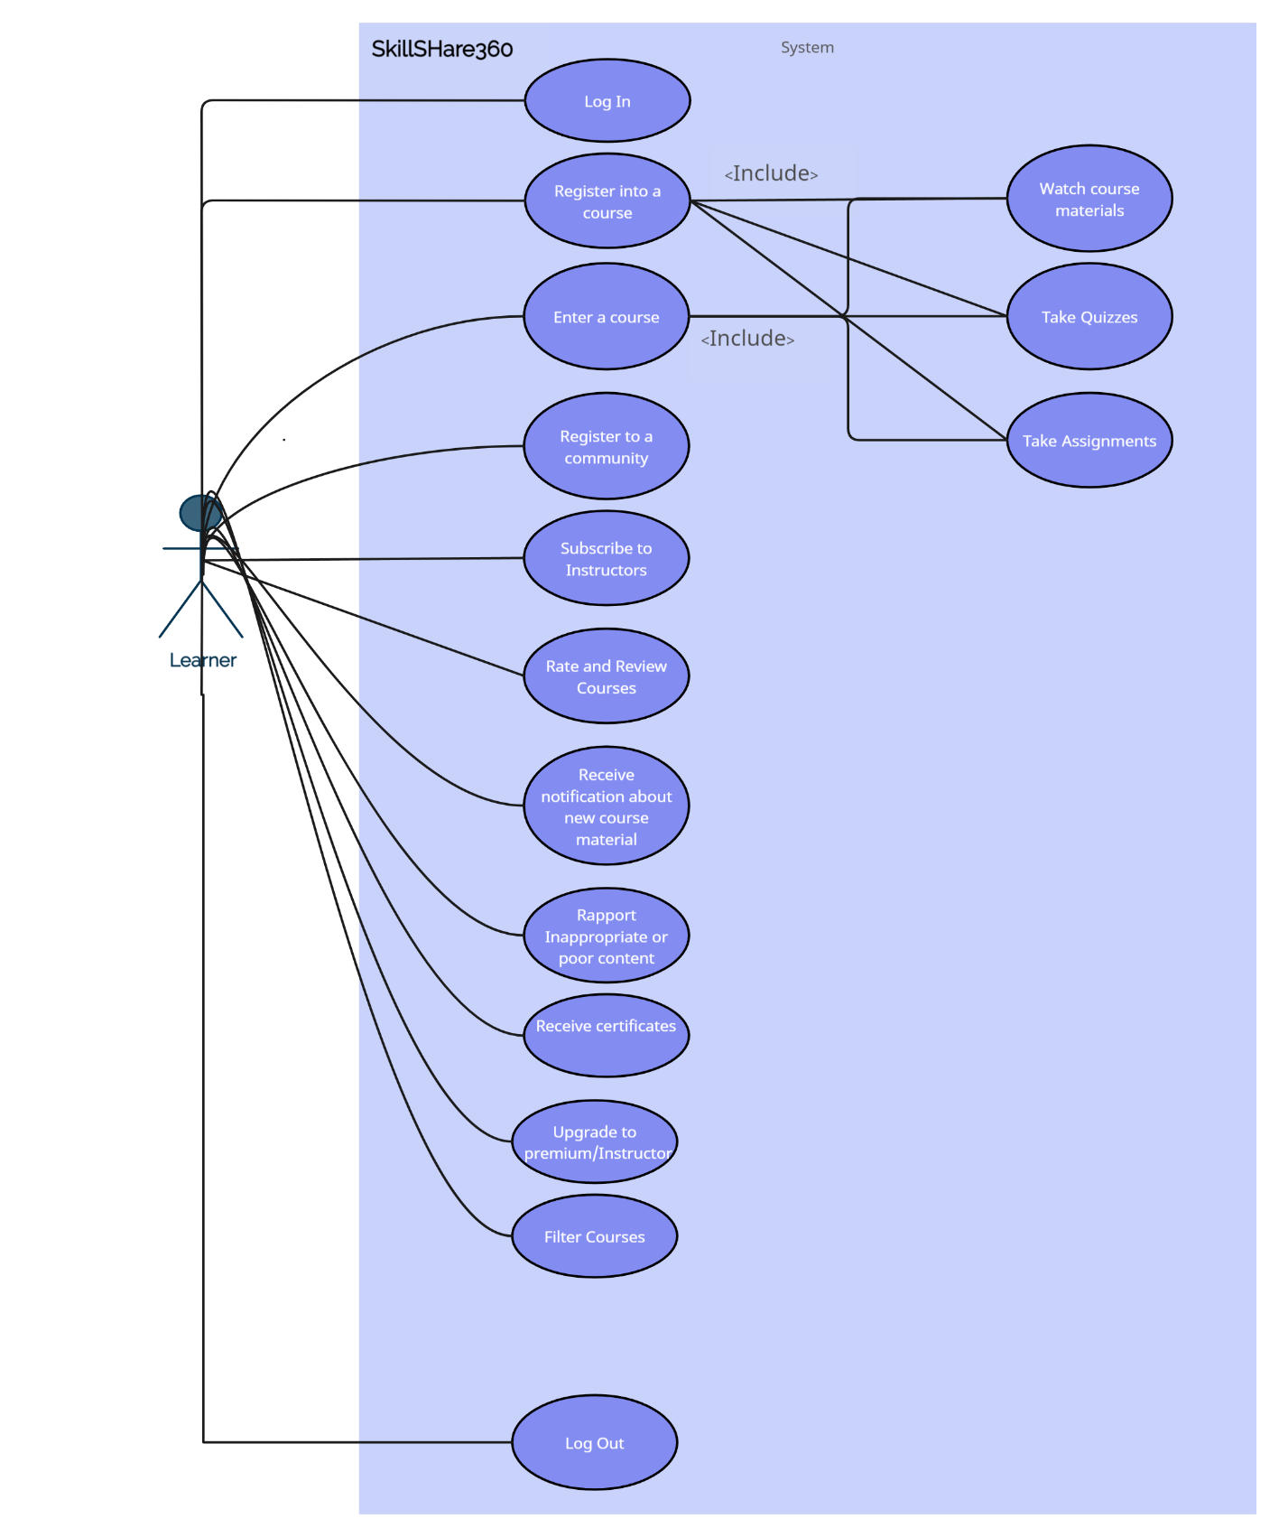

Use Case 2 Premium

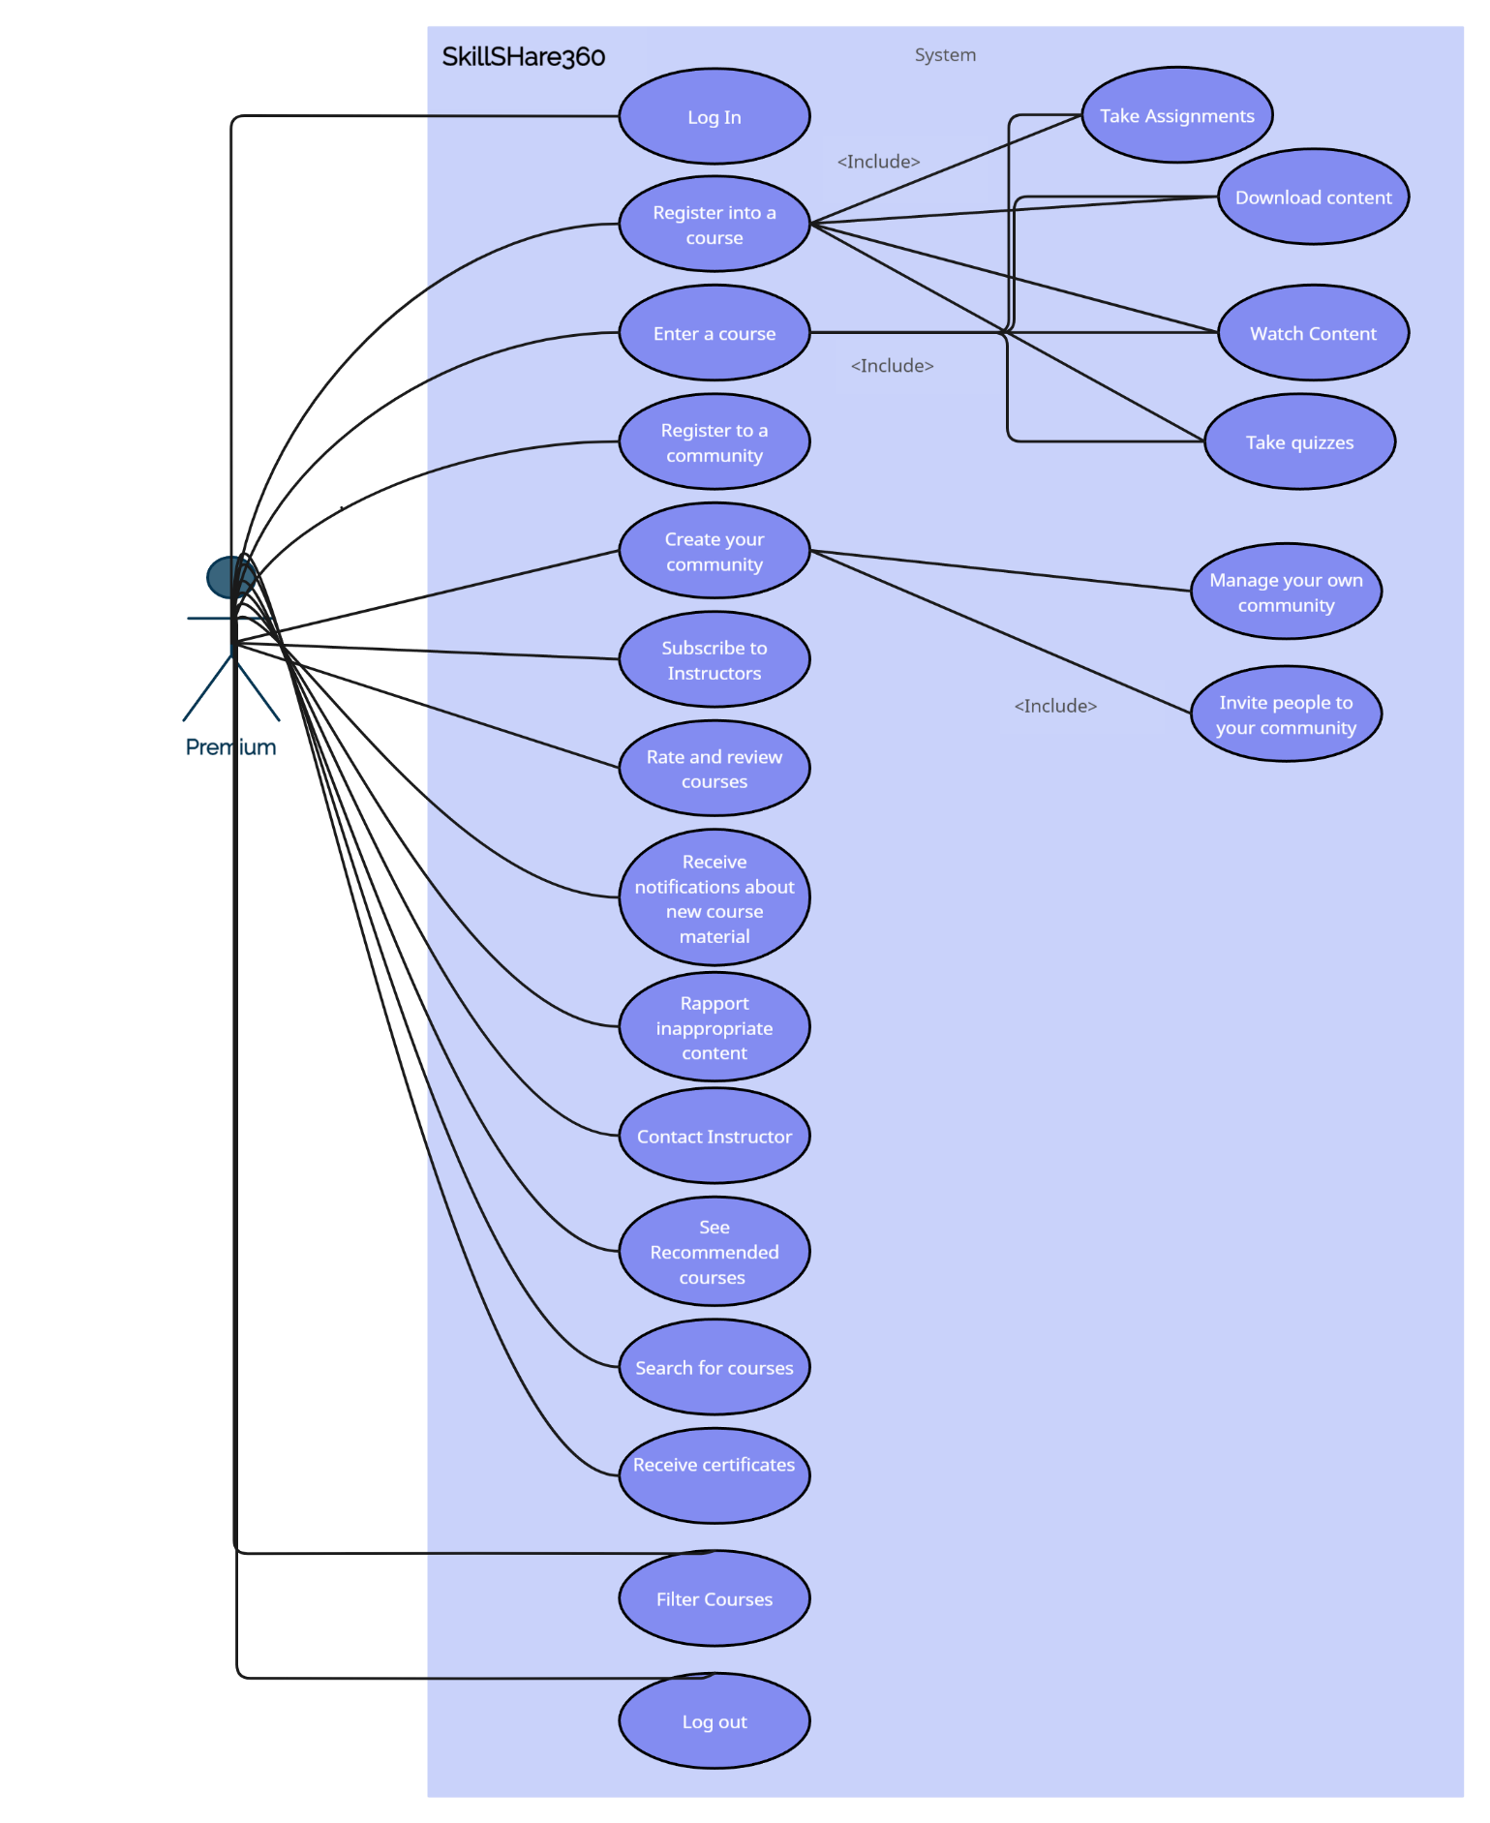

Use Case 3 Instructor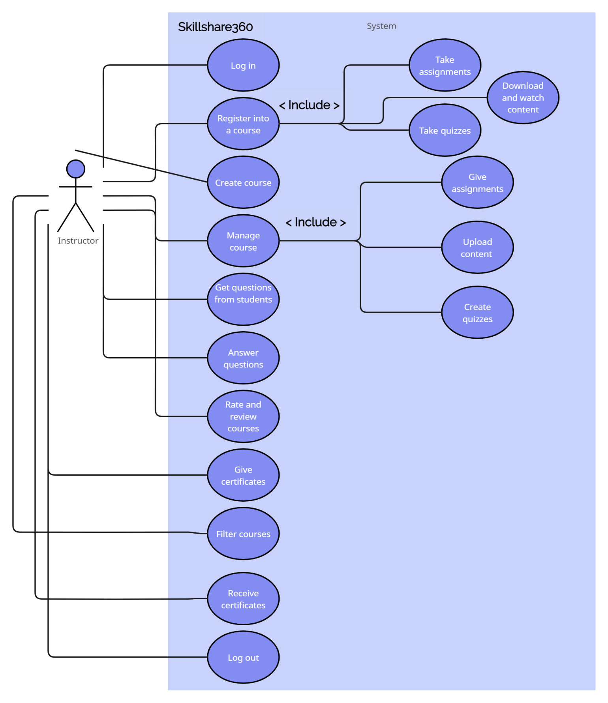

Use Case 4 General

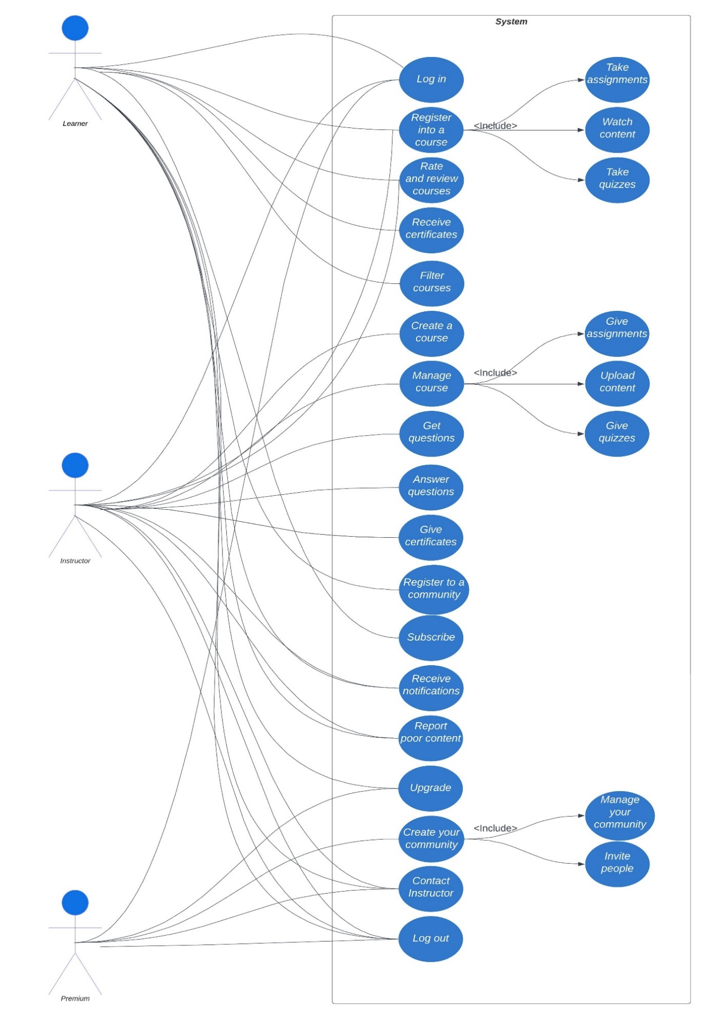

***4.7 Activity Diagrams***

#01 Log In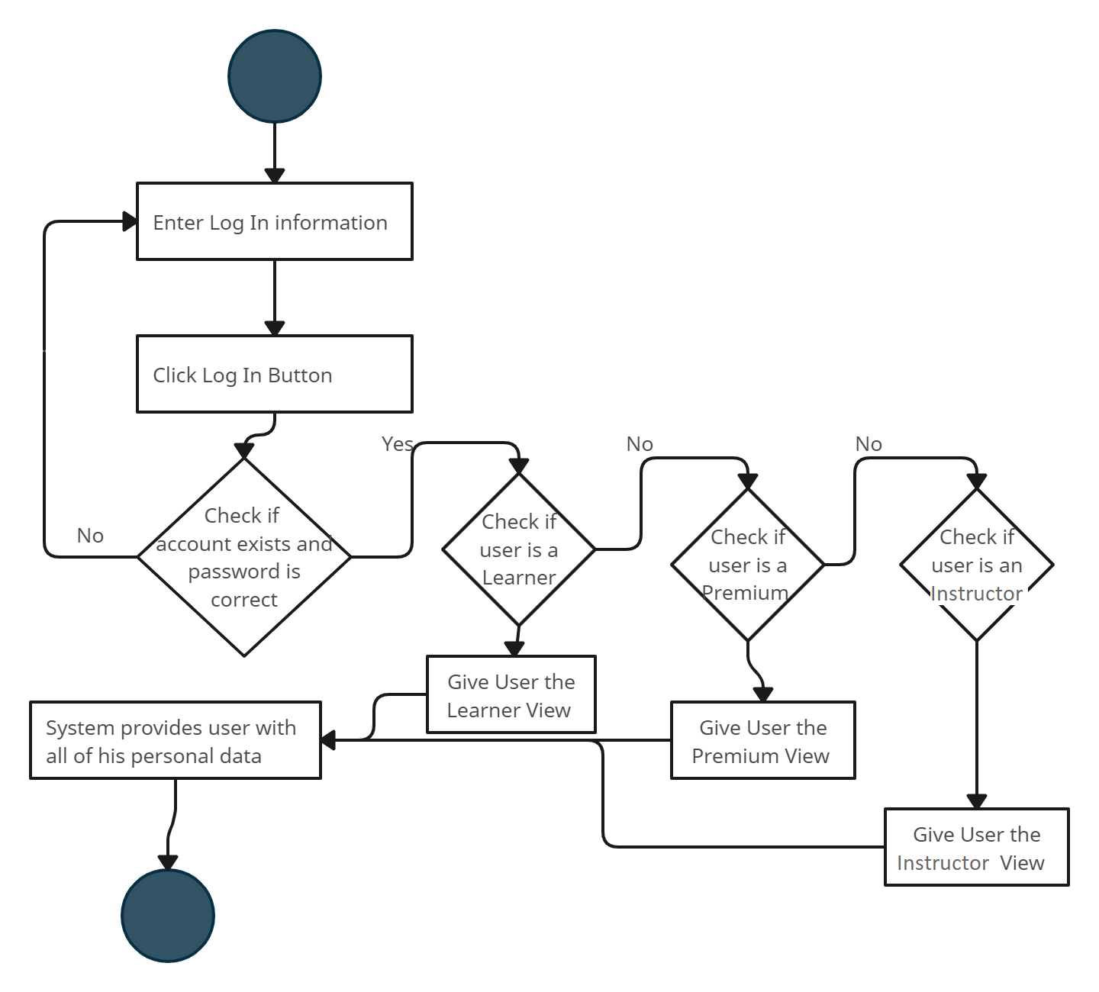

#02 Sign Up

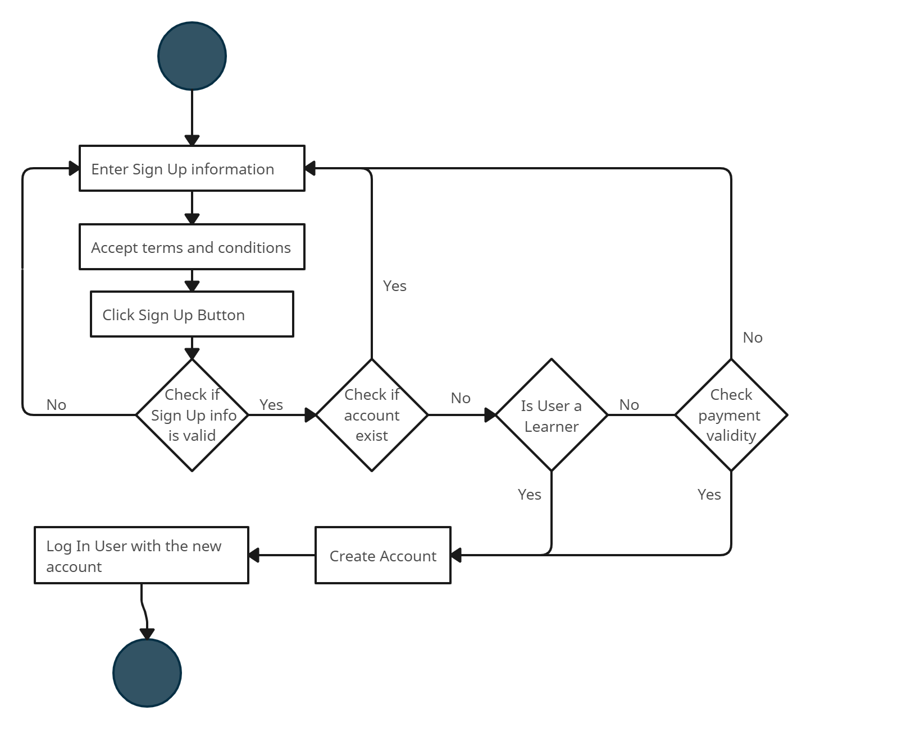

#03 Create Course

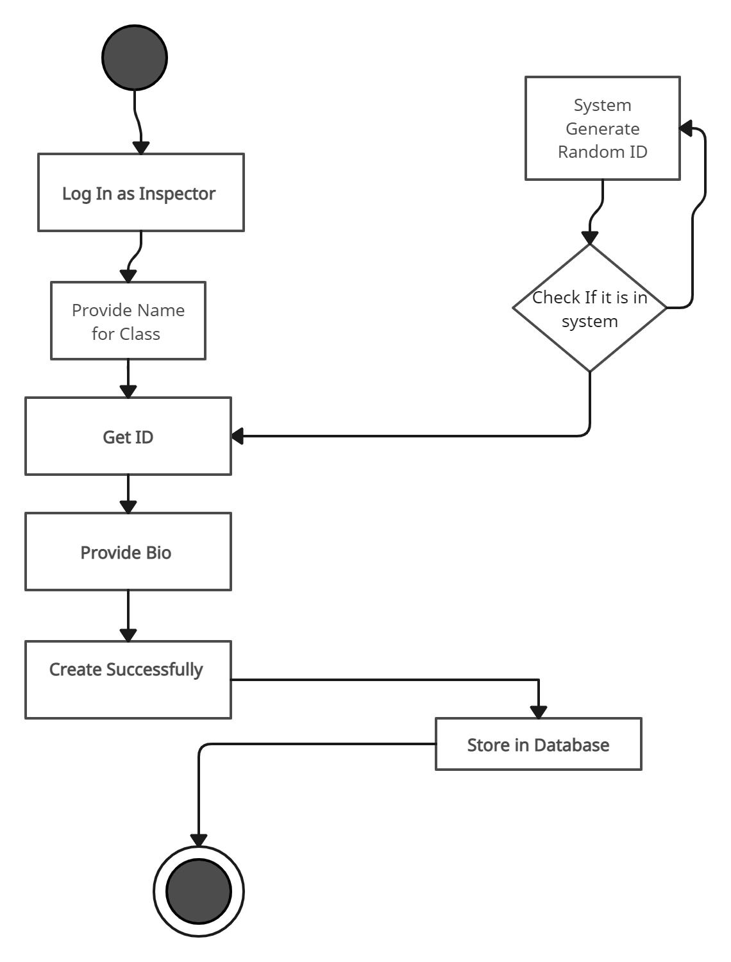

#04 Register Course

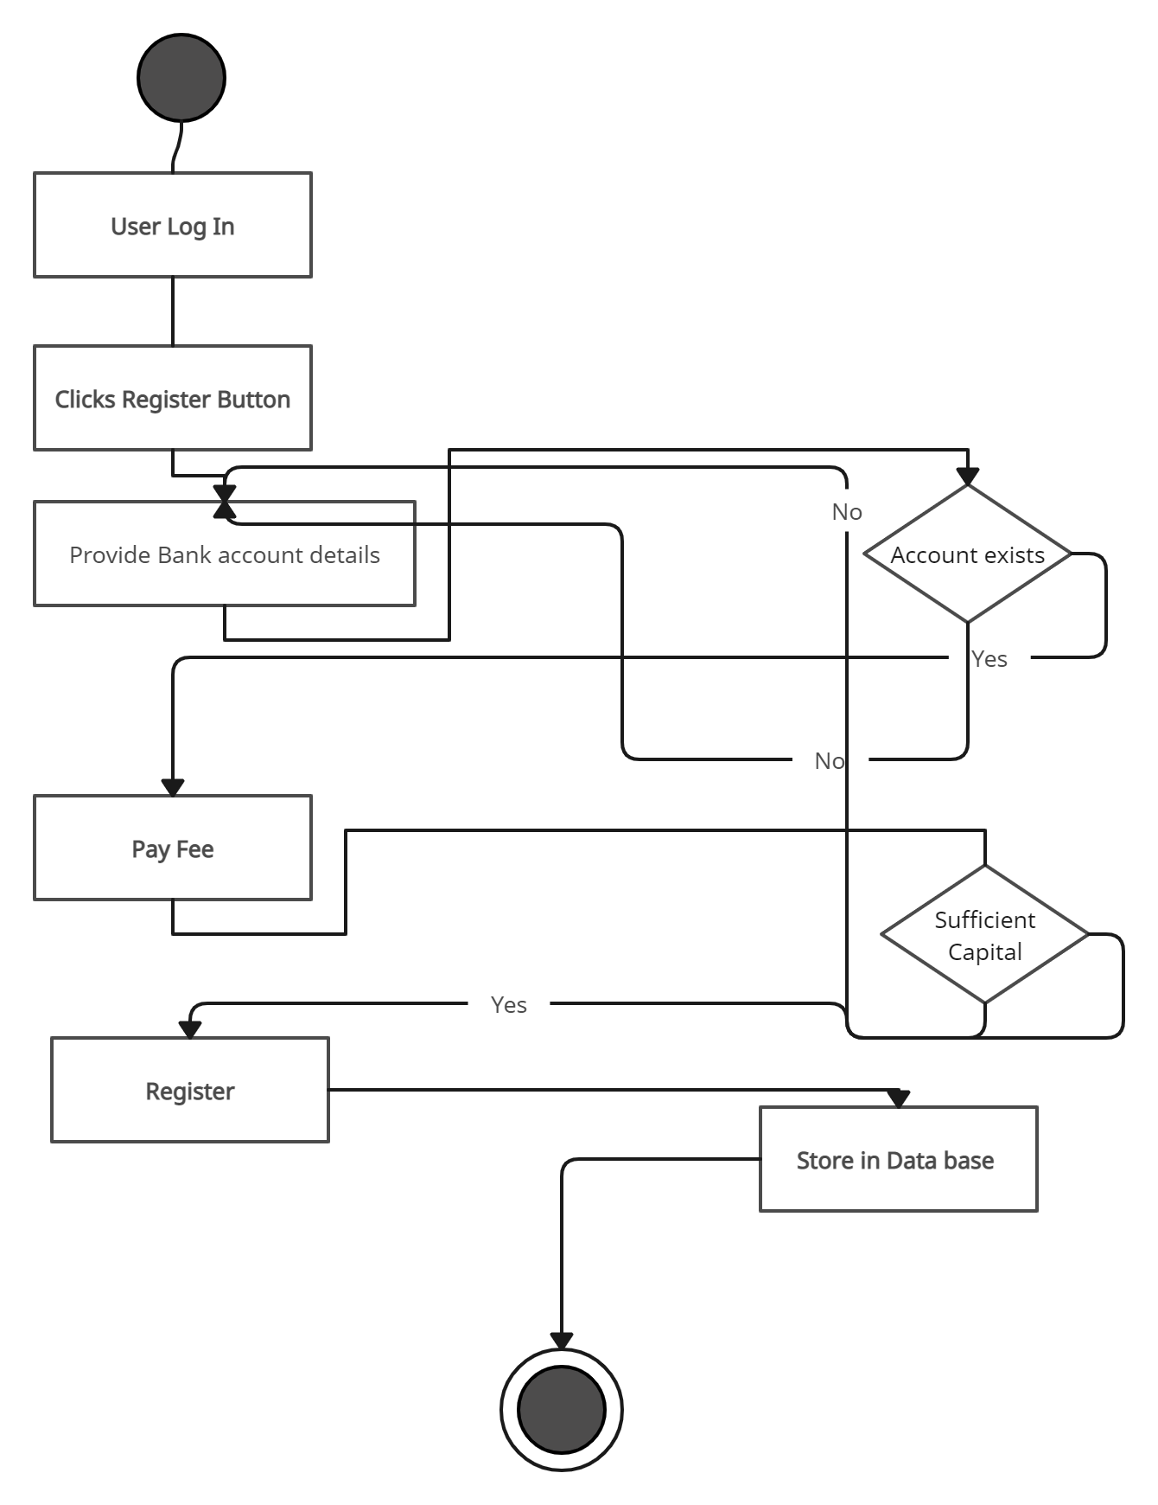

#05 Rate Course

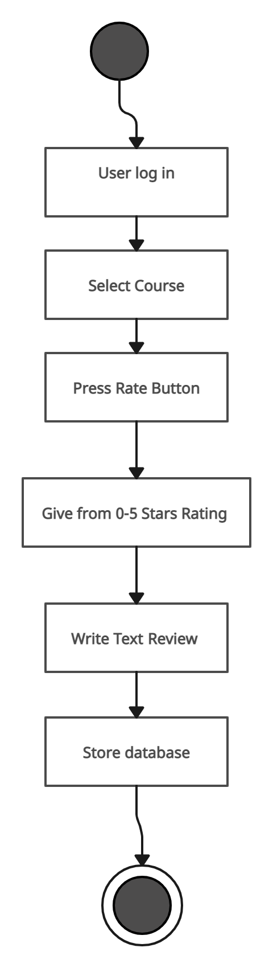

#06 Premium Creates Community

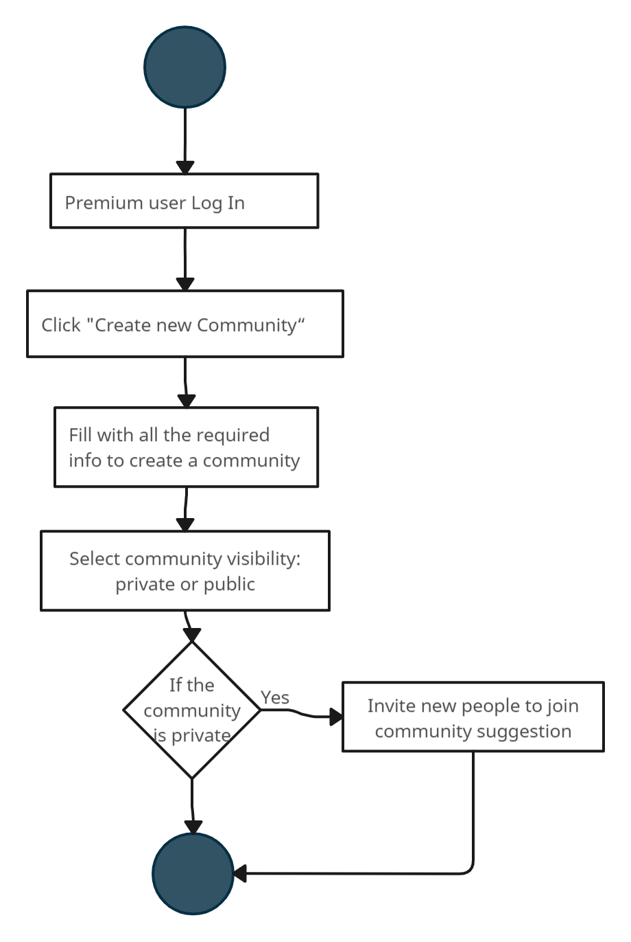

#07 User joins community

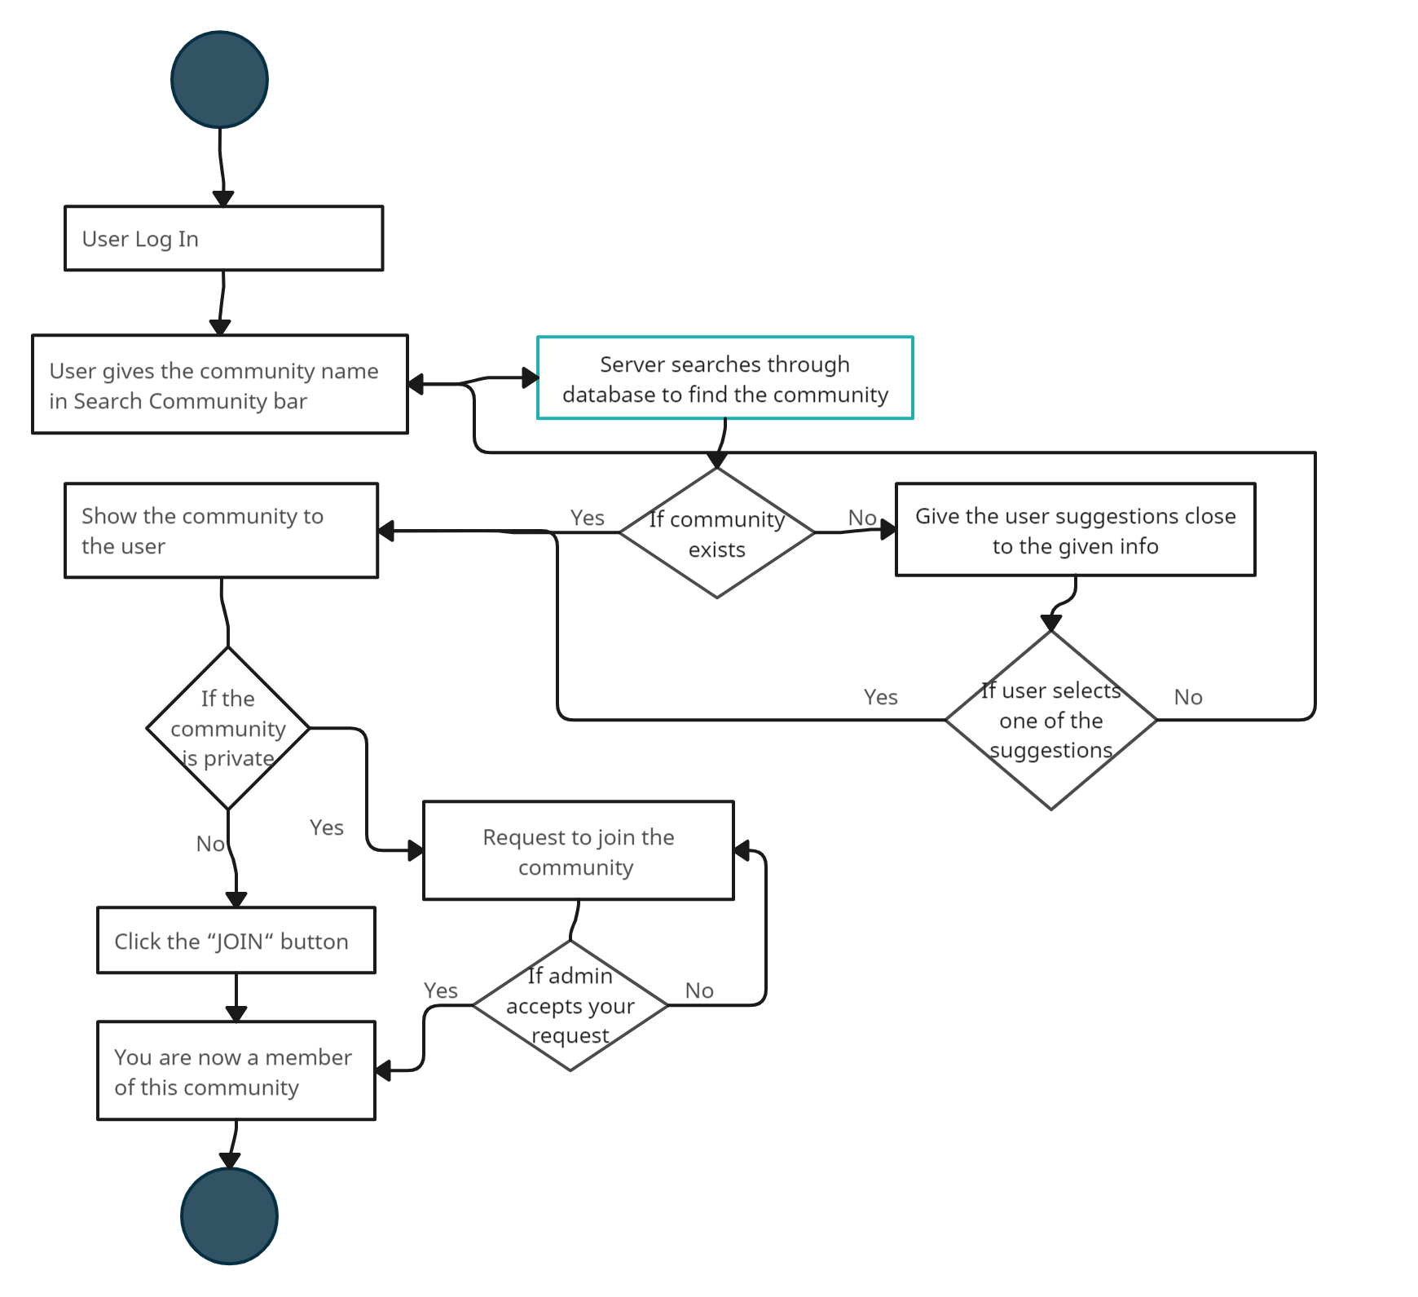

#08 Instructor adds materials

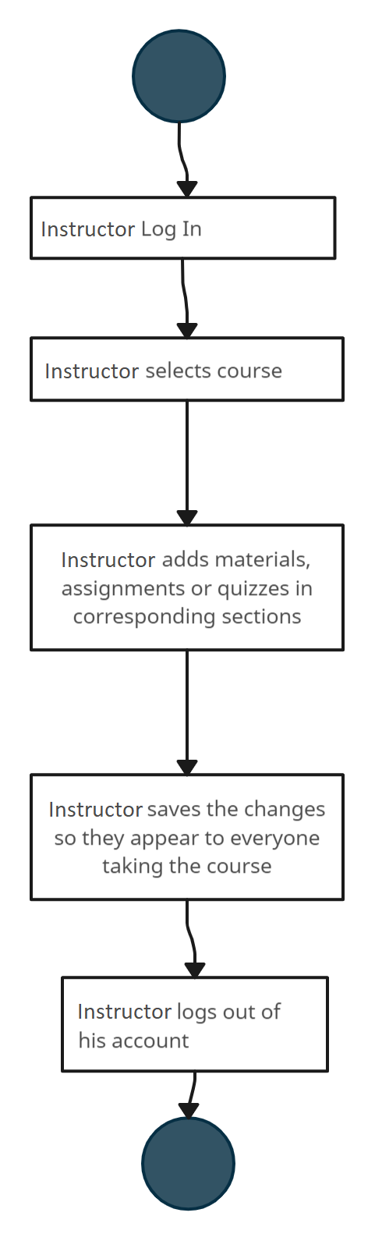

#09 Submit Question

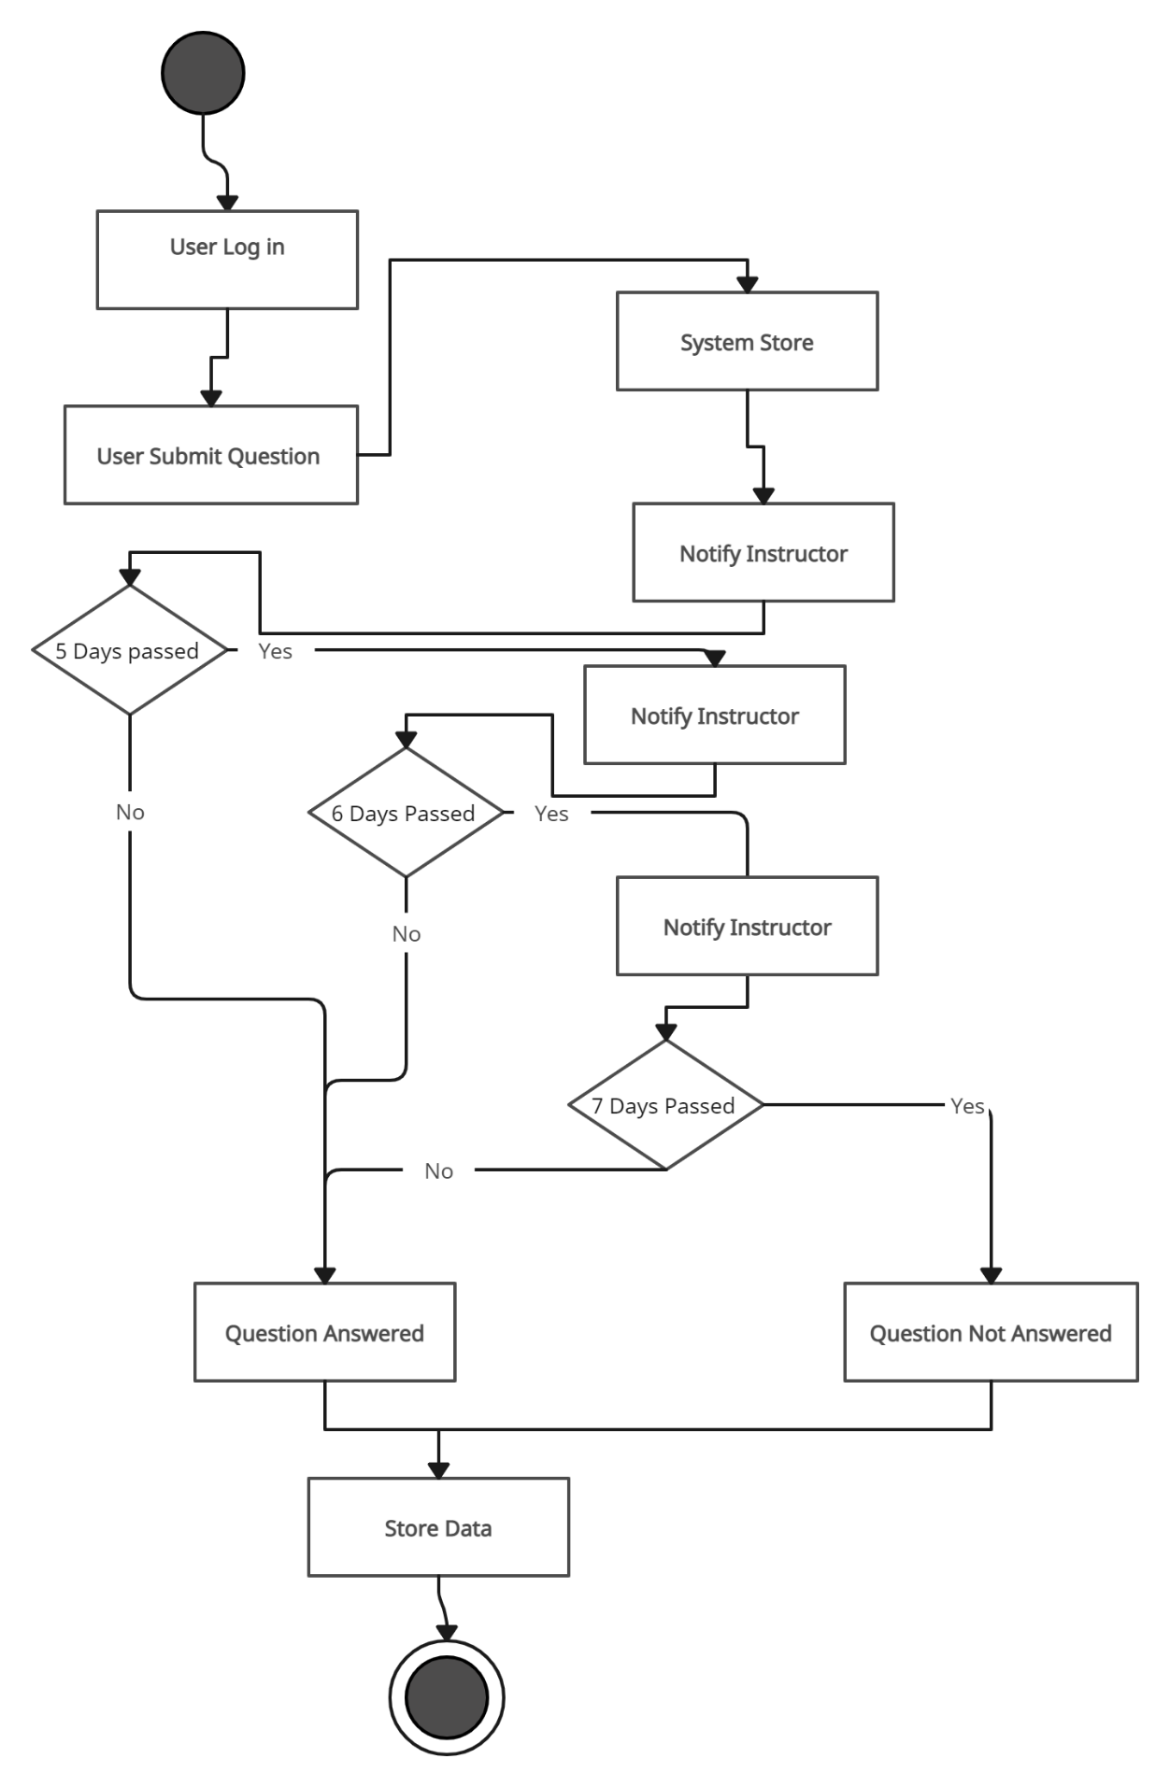

#10 User Takes Quiz

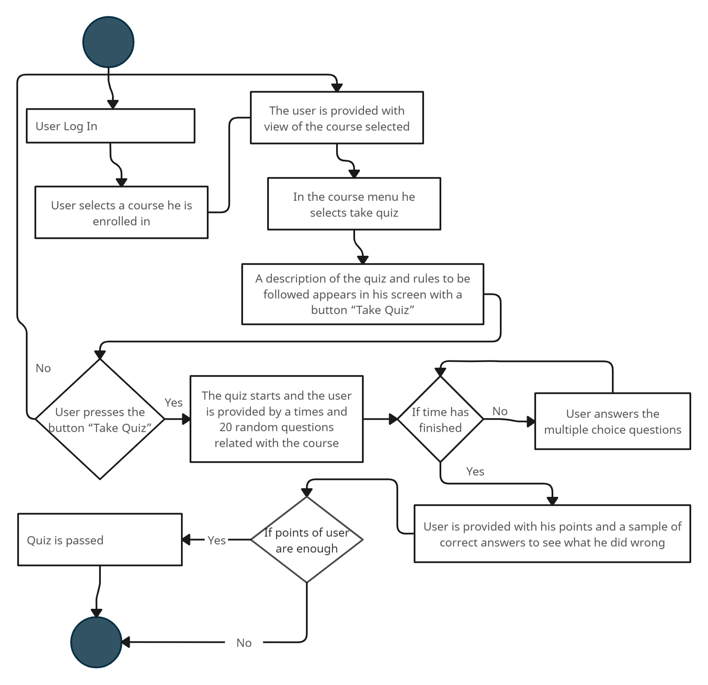

#11 Online Certificate

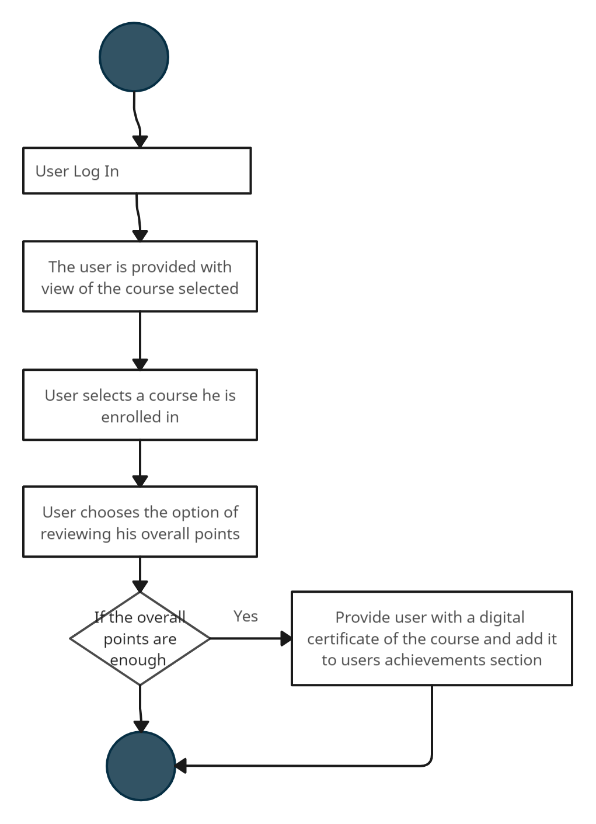

#13 Report Content

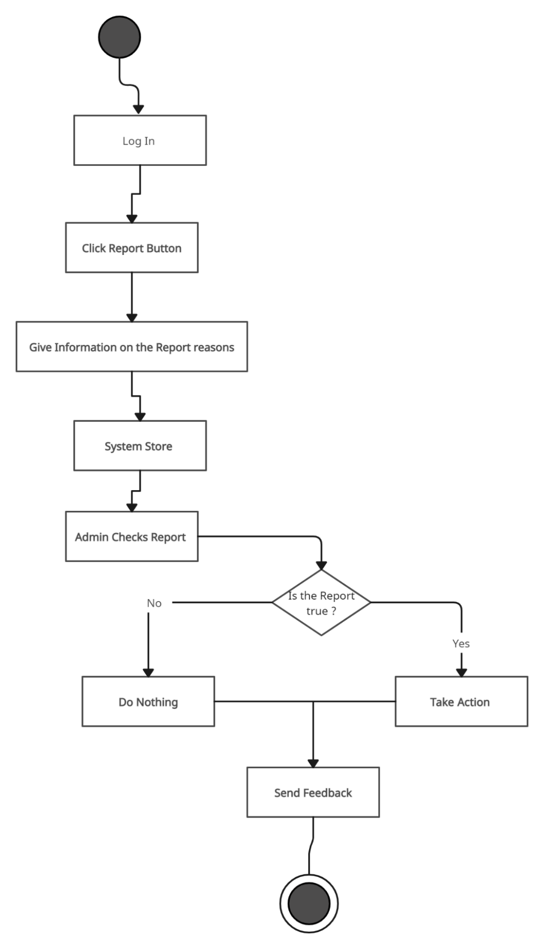

#14 Recommendation

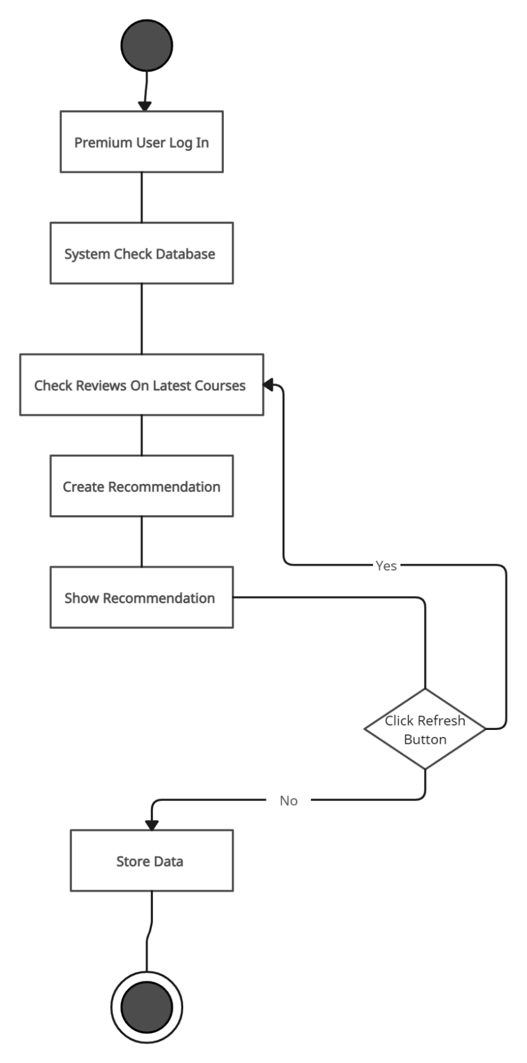

***4.9 State Diagrams***

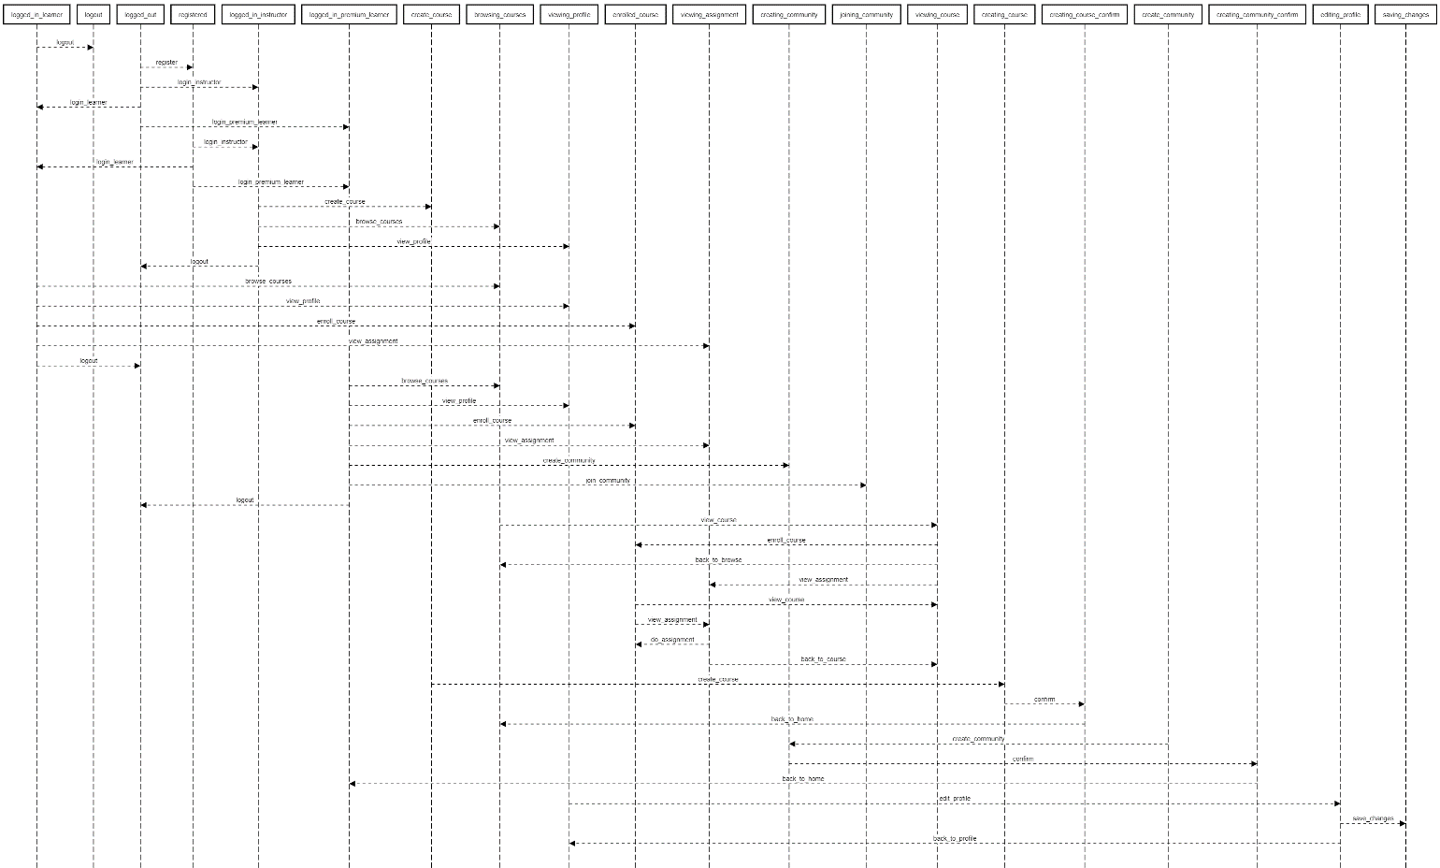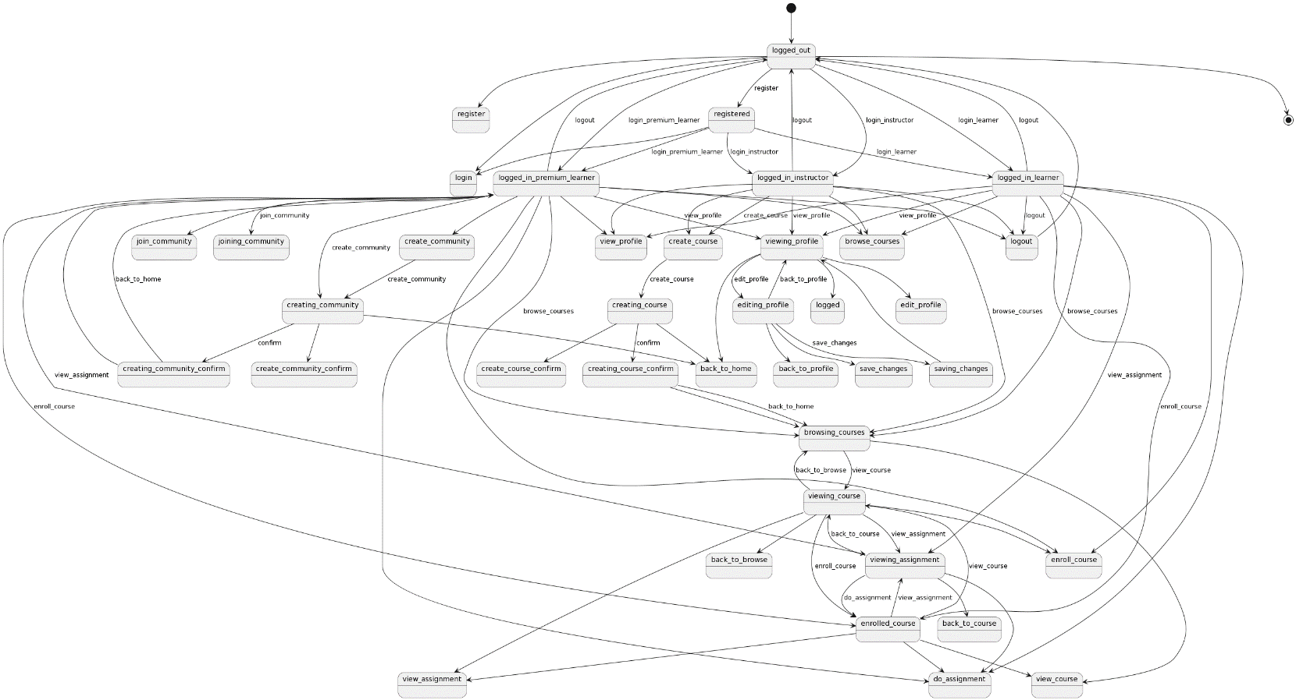

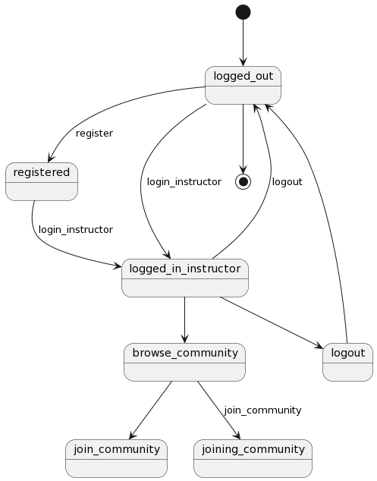

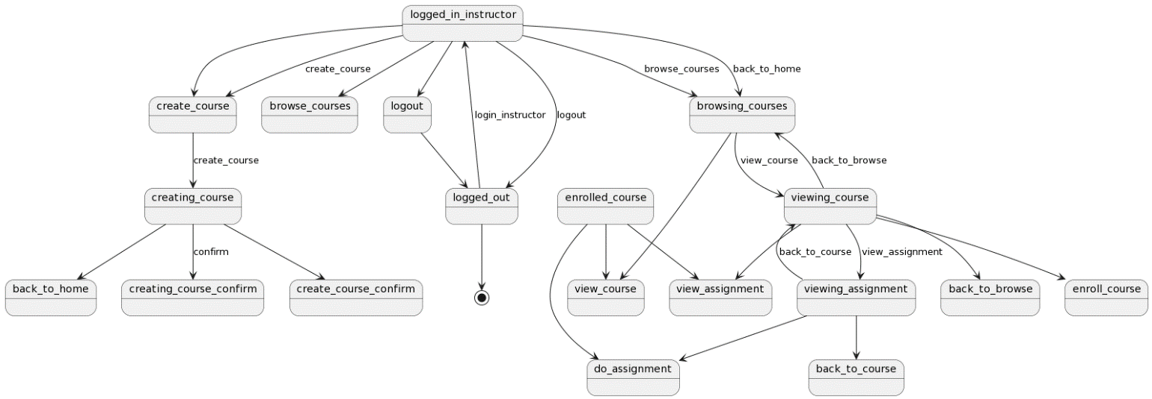

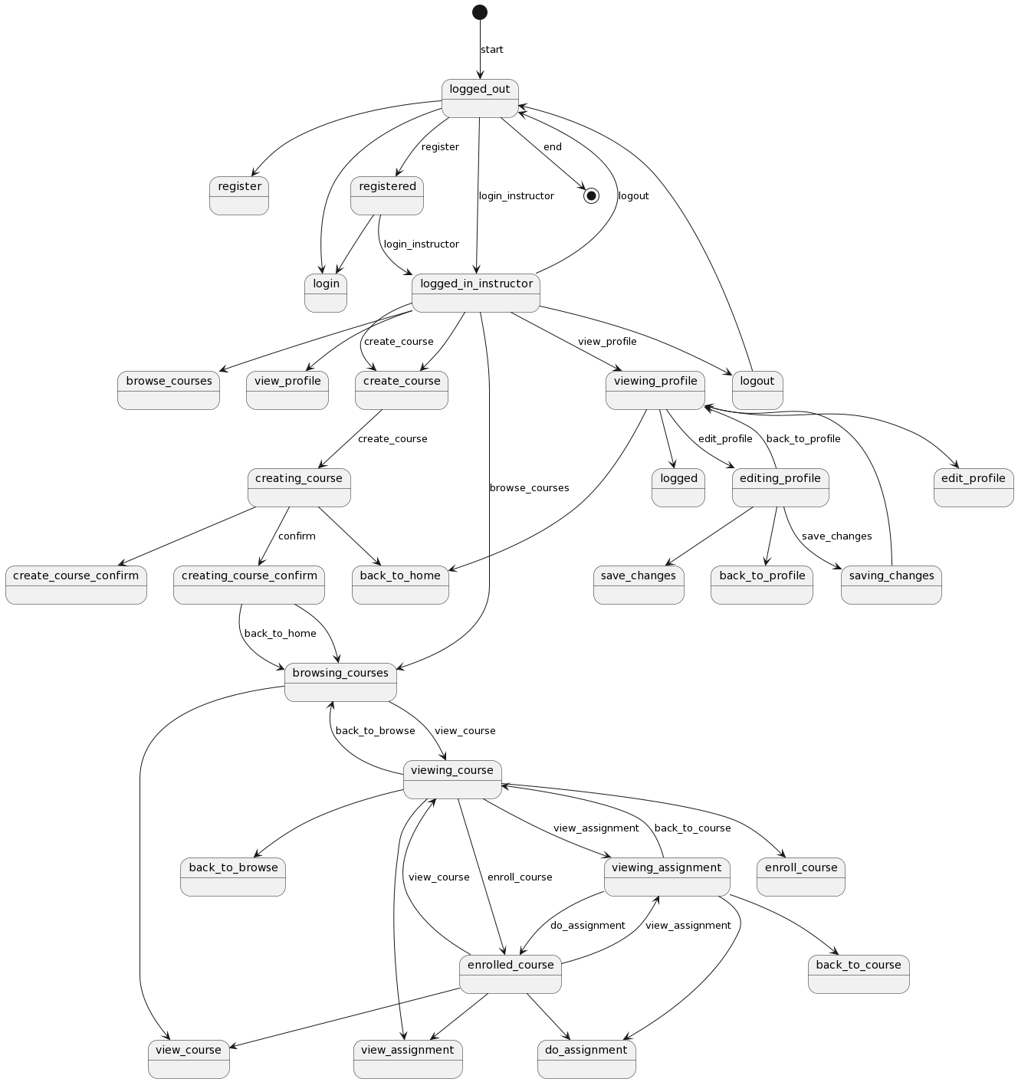

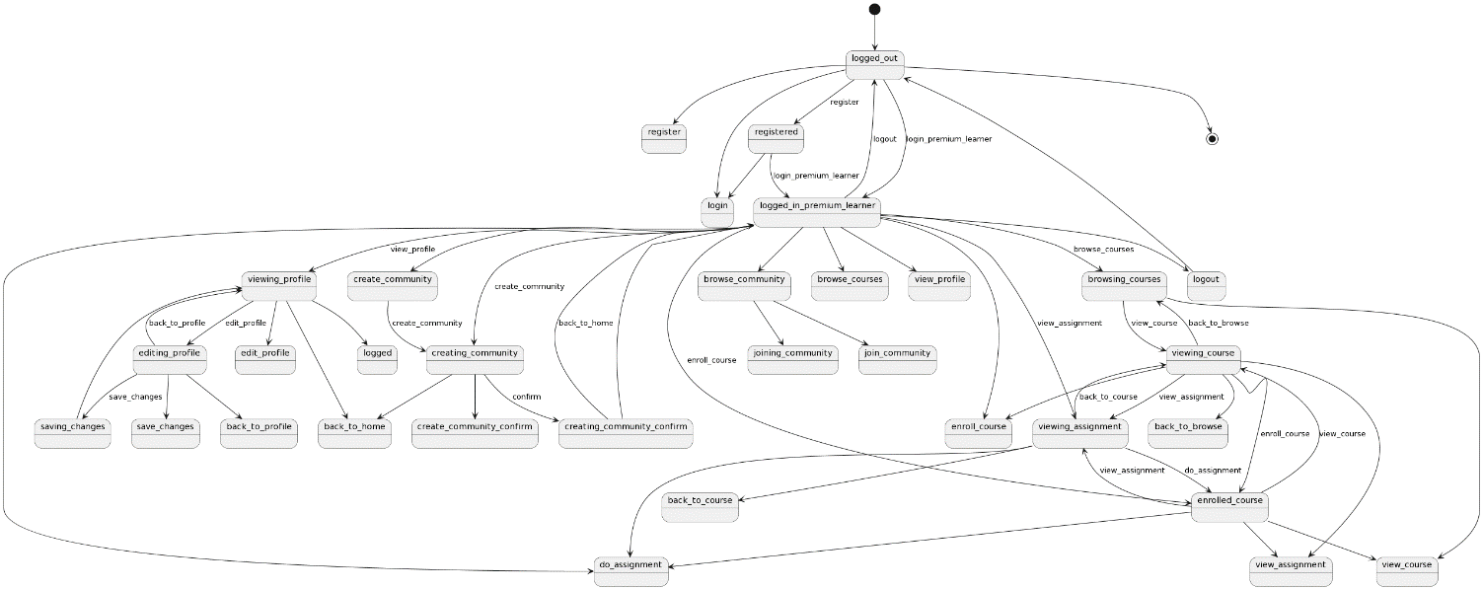

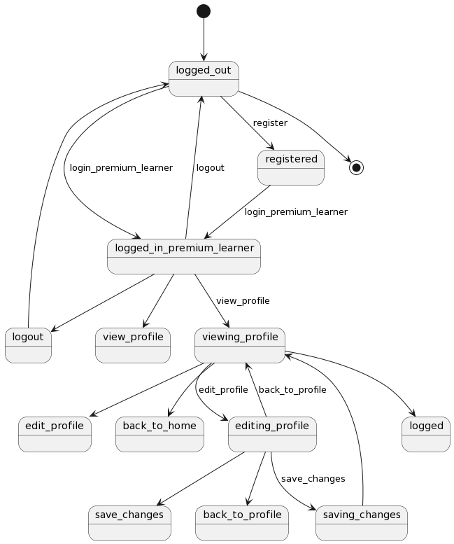

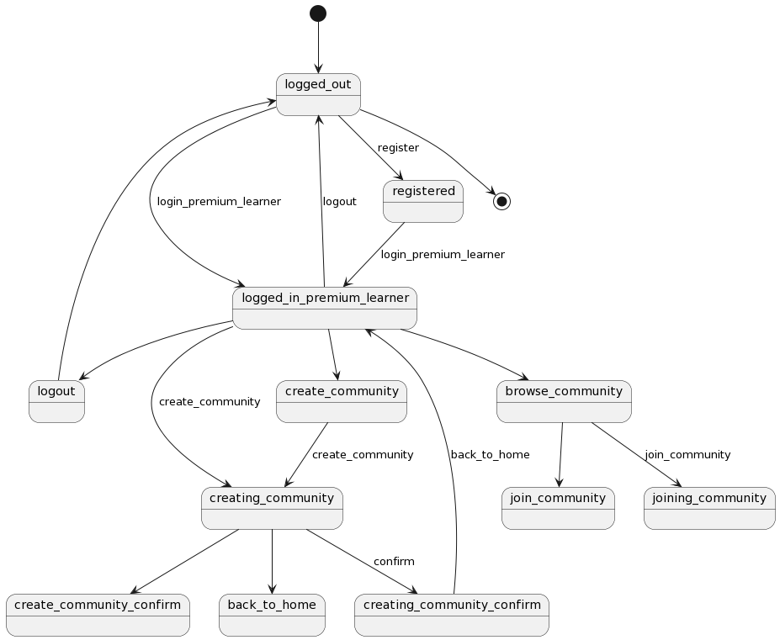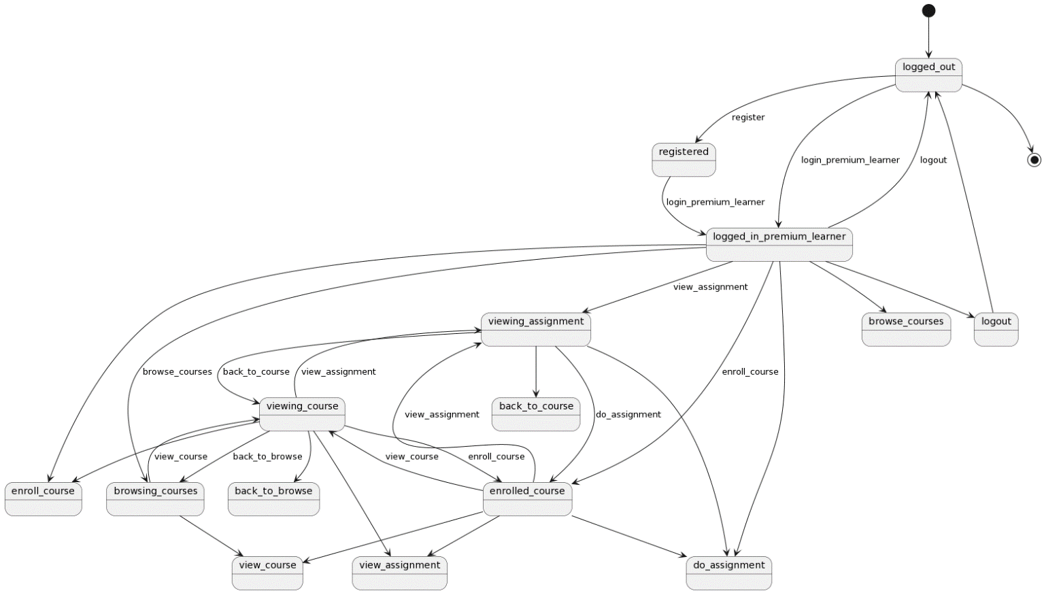

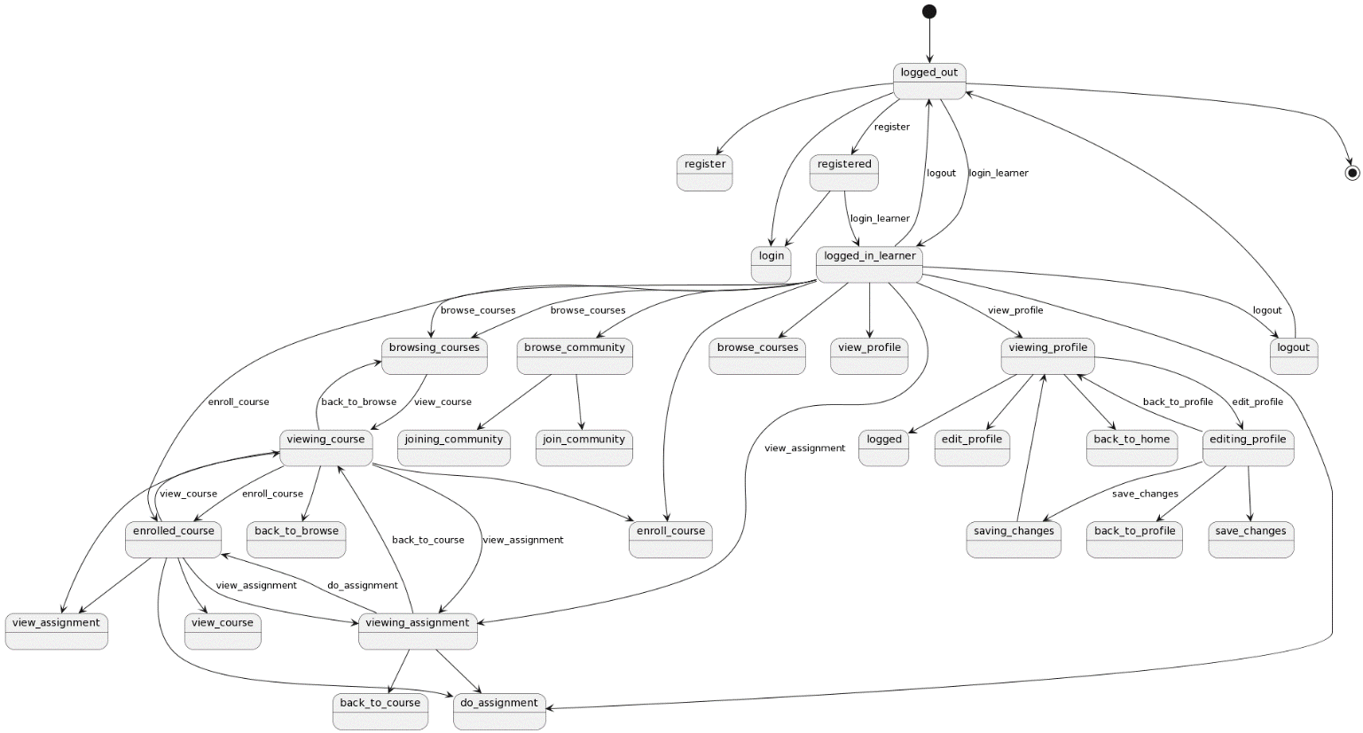

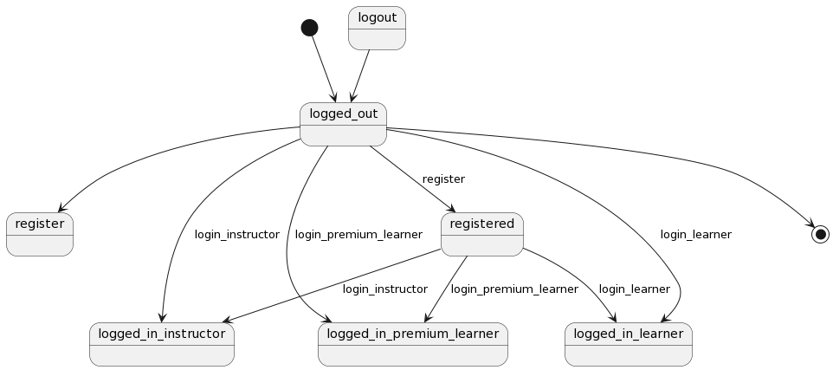

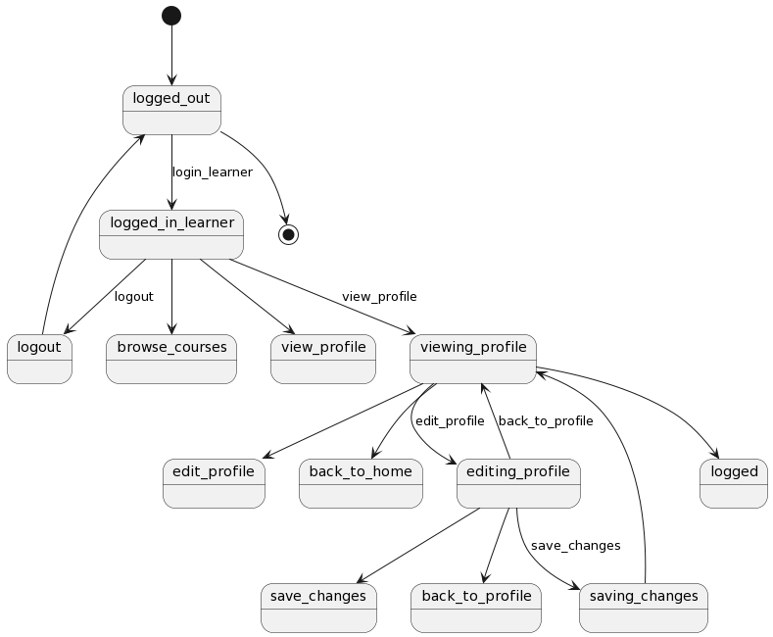

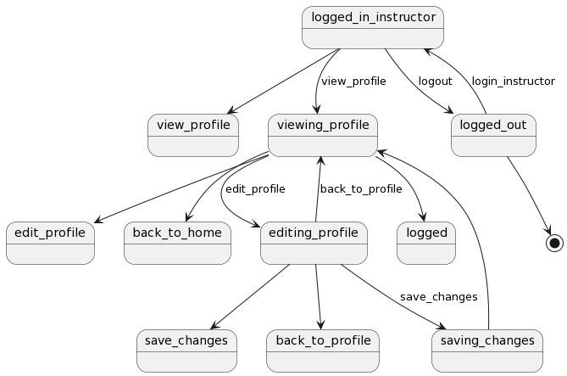

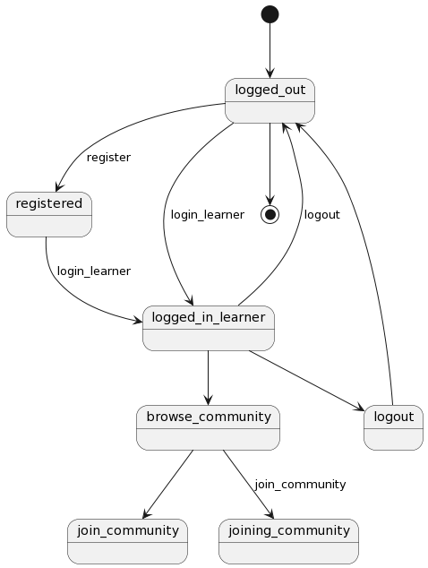

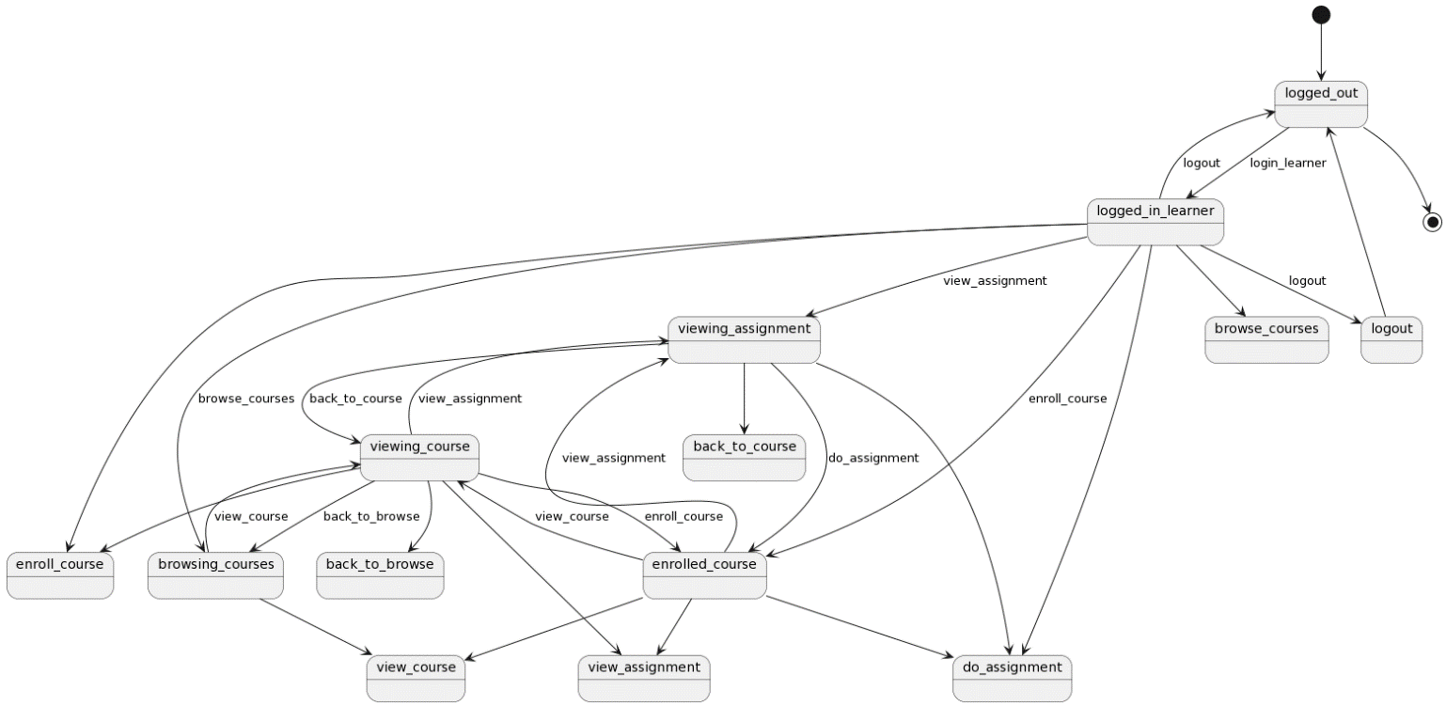

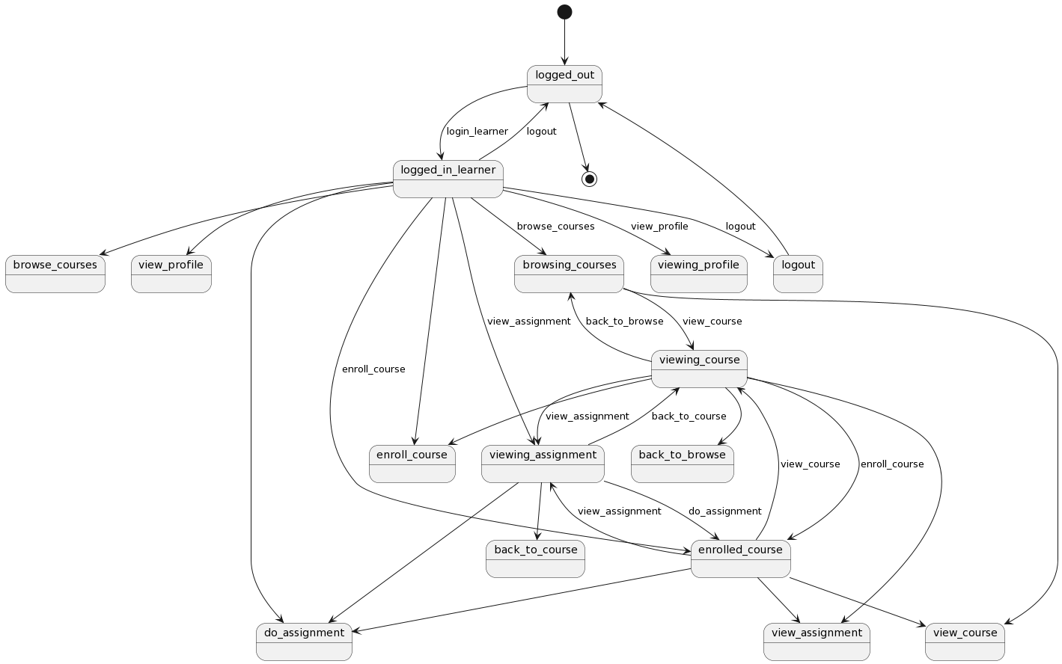

APPENDIX

The appendixes are not always considered part of the actual Requirements Specification and are not always necessary. They may include

* Sample input/output formats, descriptions of cost analysis studies, or results of user surveys;
* Supporting or background information that can help the readers of the Requirements Specification;
* A description of the problems to be solved by the system;
* Special packaging instructions for the code and the media to meet security, export, initial loading, or other requirements.

When appendixes are included, the Requirements Specification should explicitly state whether or not the appendixes are to be considered part of the requirements.

1. **Definitions, Acronyms, and Abbreviations**

Define all terms, acronyms, and abbreviations used in this document.

1. **References**

List all the documents and other materials referenced in this document.

1. **Requirements Traceability Matrix**

The following trace matrix examples show one possible use of naming standards for deliverables (FunctionalArea-DocType-NN). The number has no other meaning than to keep the documents unique. For example, the Bargaining Unit Assignment Process Flow would be BUA-PF-01.

For example (1):

| **Business Requirement** | **Area** | **Deliverables** | **Status** |
| --- | --- | --- | --- |
| BR_LR_01  The system should validate the relationship between Bargaining Unit/Location and Job Class.---Comments: Business Process = "Assigning a Bargaining Unit to an Appointment" (Priority 1) | BUA | BUA-CD-01  Assign BU Conceptual Design | Accepted |
| BUA-PF-01  Derive Bargaining Unit-Process Flow Diagram | Accepted |
| BUA-PF-01  Derive Bargaining Unit-Process Flow Diagram | Accepted |
| BR_LR_09  The system should provide the capability for the Labor Relations Office to maintain the job class/union relationship.---Comments: Business Process = "Maintenance" (Priority 1) | BUA | BUA-CD-01  Assign BU Conceptual Design | Accepted |
| BUA-PF-02  BU Assignment Rules Maint Process Flow Diagram | ReadyForReview |

For example (2):

| **BizReqID** | **Pri** | **Major Area** | **DevTstItems DelivID** | **Deliv Name** | **Status** |
| --- | --- | --- | --- | --- | --- |
| BR_LR_01 | 1 | BUA | BUA-CD-01 | Assign BU Conceptual Design | Accepted |
| BR_LR_01 | 1 | BUA | BUA-DS-02 | Bargaining Unit Assignment DB Modification Description | Accepted |
| BR_LR_01 | 1 | BUA | BUA-PF-01 | Derive Bargaining Unit-Process Flow Diagram | Accepted |
| BR_LR_01 | 1 | BUA | BUA-UCD-01 | BU Assign LR UseCase Diagram | ReadyForReview |
| BR_LR_01 | 1 | BUA | BUA-UCT-001 | BU Assignment by PC UseCase - Add Appointment and Derive UBU | Reviewed |
| BR_LR_01 | 1 | BUA | BUA-UCT-002 | BU Assignment by PC UseCase - Add Appointment (UBU Not Found) | Reviewed |
| BR_LR_01 | 1 | BUA | BUA-UCT-006 | BU Assignment by PC UseCase - Modify Appointment (Removed UBU) | Reviewed |
| BR_LR_09 | 1 | BUA | BUA-CD-01 | Assign BU Conceptual Design | Accepted |
| BR_LR_09 | 1 | BUA | BUA-DS-02 | Bargaining Unit Assignment DB Modification Description | Accepted |
| BR_LR_09 | 1 | BUA | BUA-PF-02 | BU Assignment Rules Maint Process Flow Diagram | Accepted |
| BR_LR_09 | 1 | BUA | BUA-UCD-03 | BU Assign Rules Maint UseCase Diagram | Reviewed |
| BR_LR_09 | 1 | BUA | BUA-UCT-045 | BU Assignment Rules Maint: Successfully Add New Assignment Rule | Reviewed |
| BR_LR_09 | 1 | BUA | BUA-UCT-051 | BU Assignment Rules MaintUseCase: Modify Rule | Reviewed |
| BR_LR_09 | 1 | BUA | BUA-UCT-053 | BU Assignment Rules MaintUseCase - Review Assignment Rules | Reviewed |
| BR_LR_09 | 1 | BUA | BUA-UCT-057 | BU Assignment Rules MaintUseCase: Inactivate Last Rule for a BU | Reviewed |
| BR_LR_09 | 1 | BUA | BUA-UI-02 | BU AssignRules Maint UI Mockups | ReadyForReview |
| BR_LR_09 | 1 | BUA | BUA-TC-021 | BU Assignment Rules Maint TestCase: Add New Rule (Associated Job Class Does Not Exist) - Success | ReadyForReview |
| BR_LR_09 | 1 | BUA | BUA-TC-027 | BU Assignment Rules Maint TestCase: Modify Rule - Success | ReadyForReview |
| BR_LR_09 | 1 | BUA | BUA-TC-035 | BU Assignment Rules Maint TestCase: Add New Rule (Associated Job Class Does Not Exist) - Error Condition | ReadyForReview |
| BR_LR_09 | 1 | BUA | BUA-TC-049 | BU Assignment Rules Maint TestCase: Modify Rule - Error Condition | ReadyForReview |

For example (3):

| **BizReqID** | **CD01** | **CD02** | **CD03** | **CD04** | **UI01** | **UI02** | **UCT01** | **UCT02** | **UCT03** | **TC01** | **TC02** | **TC03** | **TC04** |
| --- | --- | --- | --- | --- | --- | --- | --- | --- | --- | --- | --- | --- | --- |
| BR_LR_01 |  |  | X |  | X |  | X |  |  | X |  | X |  |
| BR_LR_09 | X |  |  | X |  | X |  |  | X |  | X |  | X |
| BR_LR_10 | X |  |  | X |  |  |  |  | X |  | X |  |  |
| BR_LR_11 |  | X |  |  |  |  |  |  |  |  |  |  |  |

1. **Organizing the Requirements**

This section is for information only as an aid in preparing the requirements document.

Detailed requirements tend to be extensive. Give careful consideration to your organization scheme. Some examples of organization schemes are described below:

**By System Mode**

Some systems behave quite differently depending on the mode of operation. For example, a control system may have different sets of functions depending on its mode: training, normal, or emergency.

**By User Class**

Some systems provide different sets of functions to different classes of users. For example, an elevator control system presents different capabilities to passengers, maintenance workers, and fire fighters.

**By Objects**

Objects are real-world entities that have a counterpart within the system. For example, in a patient monitoring system, objects include patients, sensors, nurses, rooms, physicians, medicines, etc. Associated with each object is a set of attributes (of that object) and functions (performed by that object). These functions are also called services, methods, or processes. Note that sets of objects may share attributes and services. These are grouped together as classes.

**By Feature**

A feature is an externally desired service by the system that may require a sequence of inputs to affect the desired result. For example, in a telephone system, features include local call, call forwarding, and conference call. Each feature is generally described in a sequence of stimulus-response pairs, and may include validity checks on inputs, exact sequencing of operations, responses to abnormal situations, including error handling and recovery, effects of parameters, relationships of inputs to outputs, including input/output sequences and formulas for input to output.

**By Stimulus**

Some systems can be best organized by describing their functions in terms of stimuli. For example, the functions of an automatic aircraft landing system may be organized into sections for loss of power, wind shear, sudden change in roll, vertical velocity excessive, etc.

**By Response**

Some systems can be best organized by describing all the functions in support of the generation of a response. For example, the functions of a personnel system may be organized into sections corresponding to all functions associated with generating paychecks, all functions associated with generating a current list of employees, etc.

**By Functional Hierarchy**

When none of the above organizational schemes prove helpful, the overall functionality can be organized into a hierarchy of functions organized by common inputs, common outputs, or common internal data access. Data flow diagrams and data dictionaries can be used to show the relationships between and among the functions and data.

**Additional Comments**

Whenever a new Requirements Specification is contemplated, more than one of the organizational techniques given above may be appropriate. In such cases, organize the specific requirements for multiple hierarchies tailored to the specific needs of the system under specification.

There are many notations, methods, and automated support tools available to aid in the documentation of requirements. For the most part, their usefulness is a function of organization. For example, when organizing by mode, finite state machines or state charts may prove helpful; when organizing by object, object-oriented analysis may prove helpful; when organizing by feature, stimulus-response sequences may prove helpful; and when organizing by functional hierarchy, data flow diagrams and data dictionaries may prove helpful.